|  |  |  |  |  |
| --- | --- | --- | --- | --- |
| School of Computing and Engineering | | |  | |
| **Title** | Coursework | | | |
| **Module** | Databases and Analytics | | | |
| **Module Code** | CPKA500 | | | |
| **Module Leader** | Dr Shidrokh Goudarzi | | | |
| **Set by:** | Dr Shidrokh Goudarzi | | | |
| **Moderated by:** |  | | | |
| **External Examiner** | Dr Joanna Hartley | | | |
| **Assignment** | Assessment 2: Coursework | | | |
| **Hand in arrangements** | Electronic submission via Blackboard and Turnitin | | | |
| **Structure of assignment** | This assignment consists of multiple tasks, each described below. Successful completion of all tasks will assess the learning outcomes of the module. | | | |
| Type | **Weighting** | | **Due Date** |
| Portfolio | 50% | | 29/ May/2025 |
| **Learning**  **outcomes** | Teach the advanced principles of databases and analytics that will enable students to write more efficient queries by understanding the internal database structure.  Provide students with the knowledge required to undertake a range of advanced techniques in data analytics.  Gain knowledge of and ability to work with modern tools for massively distributed data processing.  Ability to work with highly scalable data-storage paradigms.  Develop an understanding of common data analytics techniques used to manipulate data. | | | |
| **Coursework** | For this task, please complete the three sections.  Your coursework should highlight how you used and applied the techniques introduced in this module, including Data Analytics in R, Data Analytics in (Python - NumPy and Pandas), and analysis of operational data on MongoDB. | | | |

## 📑 Table of Contents

## Introduction  • Overview of the Module  • Purpose of the Portfolio  • Technologies and Tools Used

## Section 1: Data Analysis in R – GreenFuture Case Study  • Introduction to GreenFuture and IMS-Connect  • Problem Statement  • Objectives and Sub-Objectives  • Solution Approach  • Importing the Dataset via GitHub and Google Colab  • Executing SQL Queries in R  • Data Manipulation and Transformation using dplyr  • Data Visualization using ggplot2  • Findings and Insights  • Recommendations  • Conclusion

## Section 2: Bookstore Management Information System – Python (NumPy & Pandas)  • Introduction  • Problem Statement  • Objectives  • Methodology  • Importing and Combining Data  • Handling Missing Values  • Statistical Analysis with NumPy and Pandas  • Visualizations: Correlation Matrix, Scatter Plot, Histogram, Pair Plot  • Analysis and Interpretation  • Conclusion

## Section 3: Operational Data Analysis with MongoDB  • Introduction  • Problem Statement  • Proposed Solution  • Objectives  • NoSQL Schema Design  • Data Insertion and CRUD Operations in MongoDB Atlas  • Querying and Aggregation Examples  • Data Visualizations using Seaborn and Matplotlib  • Analysis and Findings  • Conclusion

## Section 1

**Introduction:**

Green Future, a global leader in sustainability consulting, faced a stagnation in innovation despite its highly skilled and distributed workforce. In response, it implemented IMS-Connect, a global Innovation Management System aimed at collecting, evaluating, and developing employee-generated ideas. However, the transition introduced cultural, technical, and operational challenges. This project uses real-world data from Green Future’s innovation platform to explore trends in idea submission, participation, approval, and collaboration through SQL-based analysis in R.

**✅ Problem Statement:**

Green Future implemented IMS-Connect to enhance innovation, but faced key issues:

* Disparities in participation and access across global offices.
* An overwhelming number of idea submissions with no streamlined filtering or evaluation.
* A competitive reward system that reduced collaboration.
* Concerns regarding data privacy and technical infrastructure.
* Lack of visibility into approval trends and collaboration effectiveness.

## ✅ **Objective:**

* To analyze and uncover patterns in idea generation, approval, and collaboration using SQL queries in R for the purpose of helping Green Future improve innovation outcomes and system performance.

✅ Sub-Objectives:

1. Identify which departments and offices contribute the most ideas.
2. Analyze the approval rate and its distribution over time.
3. Determine the level of collaboration in submissions across departments.
4. Explore voting patterns to highlight popular ideas.
5. Segment ideas with above-average support (votes).
6. Visualize trends using ggplot2 to make findings intuitive.
7. Propose data-driven recommendations to enhance IMS-Connect.

✅ Solution Approach:

1. Data Preparation

* Load and clean greenfuture_ideas_dataset.csv.
* Handle missing values, ensure data types are appropriate.

2. SQL in R for Analysis

Use the sqldf or DBI and RSQLite packages to run SQL queries to:

* Aggregate idea counts by department and office location.
* Calculate average votes per idea category.
* Filter and analyze ideas based on collaboration and approval status.
* Track approval rates over time.
* Identify high-impact ideas (above-average votes).

3. Visualization

Use ggplot2 to create:

* Bar plots for idea distribution.
* Box plots for vote distribution.
* Pie charts for approval status.
* Stacked charts for collaboration by department

1)Importing the Dataset: (2 Marks)

1. How do you import the dataset to GitHub?

To add a dataset to GitHub (especially if you have signed in with your Google account, which simplifies the preliminary setup), follow these steps:

Go to GitHub: Open your internet browser and go to the GitHub website (github.com).

Sign In (if you haven't already): If you've got signed in with your Google account, you ought to already be logged in. If not, click on the "Sign in" button and use your Google account credentials.

Navigate to your Repository:

If you already have a repository the place you desire to shop the dataset, locate it in your listing of repositories.

If you want to create a new repository:

Click the "+" button in the top right corner and select "New repository".

Give your repository a name (e.g., "data-files"). You can add a description if you want.

Choose whether you prefer the repository to be "Public" or "Private". (Public is pleasant for most facts sharing purposes).

Click "Create repository".

Upload the Dataset:

Once you're in your repository, click the "Add file" button. It would possibly be a dropdown menu.

Select "Upload files".

You'll see an vicinity where you can drag and drop files. Drag your dataset file (e.g., greenfuture_ideas_dataset.csv) from your computer into this area. Alternatively, you can click "choose your files" to choose the file the use of a file dialog.

Commit the Changes:

After the file has uploaded, scroll down the page.

You'll see a container where you need to "Commit changes". This is like saving a version of your repository.

Write a quick description of what you are uploading (e.g., "Uploaded greenfuture_ideas_dataset.csv").

Click the inexperienced "Commit changes" button.

Accessing the Raw Link:

Once the file is uploaded, you want the "raw" hyperlink to access it directly. Here's how to get it:

* Go to your Repository: Navigate to the repository the place you uploaded the file.
* Find the File: Click on the title of the file you uploaded (e.g., greenfuture_ideas_dataset.csv).
* Get the Raw Link: On the file's page, you'll see a few buttons. Click the "Raw" button. This will open the file in your browser, displaying simply the uncooked data.
* Copy the URL: Copy the URL from your browser's tackle bar. This is the "raw" link.

Example Raw Link:

A uncooked link looks like this:

https://raw.githubusercontent.com/your_username/your_repository_name/main/greenfuture_ideas_dataset.csv

Replace your_username and your_repository_name with your authentic GitHub username and repository name. The primary section refers to the department where the file is saved (it would possibly be master for older repositories).

Creating a folder in GitHub

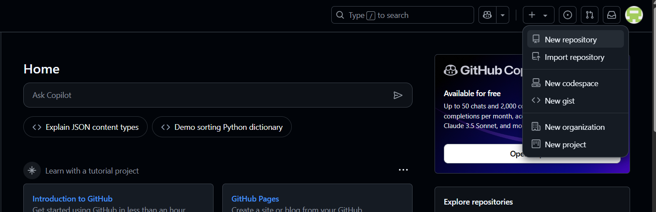

This image shows the GitHub home dashboard in dark mode. The user has clicked on the "+" (plus) icon located in the upper-right corner of the screen, which opens a dropdown menu. This menu allows users to initiate the creation or import of various GitHub entities.

Here’s a breakdown of the elements:

Top Bar:

* Search bar: Allows users to search repositories, issues, pull requests, etc.
* Icons next to the search bar: These are for notifications, creating new items, and accessing user settings or profile.

Dropdown Menu (expanded from the "+" icon):

This dropdown provides options for:

1. New repository – Create a new GitHub repository.
2. Import repository – Import code from an existing repository.
3. New codespace – Create a new development environment using GitHub Codespaces.
4. New gist – Create a new gist (a simple way to share code snippets).
5. New organization – Create a new GitHub organization.
6. New project – Start a new GitHub project (used for project management and tracking).

Left Section (Home content):

* Ask Copilot search bar: An AI assistant for code-related help.
* Suggested prompts below it (e.g., "Explain JSON content types", "Demo sorting Python dictionary").

Bottom Section:

* Tutorial project cards: Options to start learning GitHub via beginner-friendly projects (e.g., “Introduction to GitHub”, “GitHub Pages”).

Naming the folder as DBMS

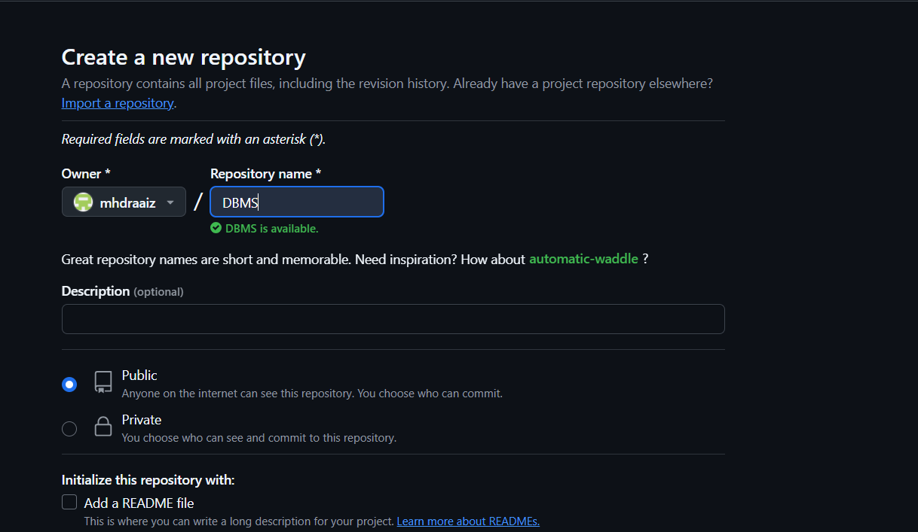

This image shows the "Create a new repository" page on GitHub.

* The user is creating a new repository with the name "DBMS" (short for Database Management System).
* The green message "DBMS is available" means the name is valid and not already in use under this account (mhdraaiz).
* The user can choose to make the repository:
  + Public (visible to everyone) – selected.
  + Private (only visible to the user and collaborators).
* There’s also an option to initialize the repository with a README file (not selected yet).

This setup will create an empty GitHub repository named DBMS, ready for version control and project collaboration.

Adding a README file

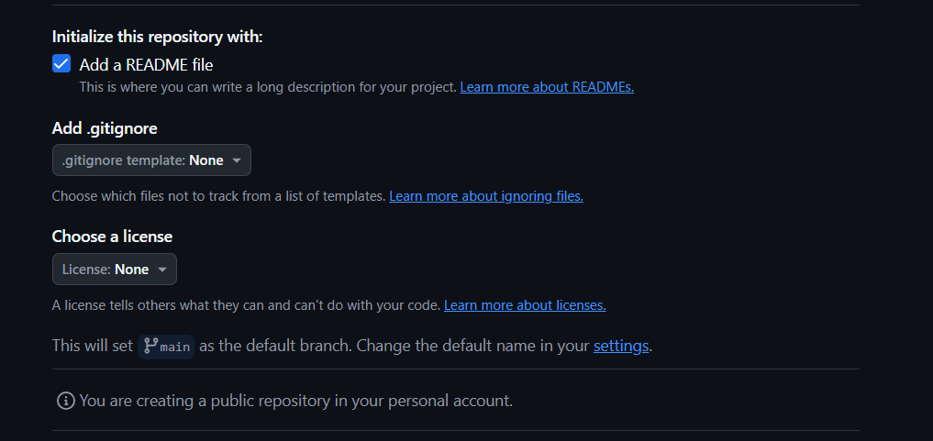

Summary:

You are setting up a new public repository on GitHub with the following options:

1. ✅ Add a README file – You are including a README file to describe the project.
2. ❌ .gitignore template not selected – No .gitignore template has been chosen.
3. ❌ License not selected – No license has been added.
4. ℹ️ The default branch will be named main.
5. 🔓 This repository will be public and part of your personal GitHub account.

Explanation of Each Option:

✅ Add a README file

* This creates a default README.md file.
* It serves as the front page of your project, where you explain what the project does, how to use it, etc.

➕ Add .gitignore

* A .gitignore file tells Git which files or folders to ignore (not track).
* Useful for ignoring temporary files, IDE settings, logs, etc.
* You haven’t selected a template, so it won’t be added unless you do.

📄 Choose a License

* A license determines what others can legally do with your code.
* Not selecting a license means others technically can’t use, modify, or distribute your code freely.

🌿 Default Branch: main

* The first branch in your repo will be called main.
* This is standard for GitHub as of recent years.

🔓 Public Repository

* Anyone on the internet can see this repository.
* You can still control who can contribute.

Creating Repository

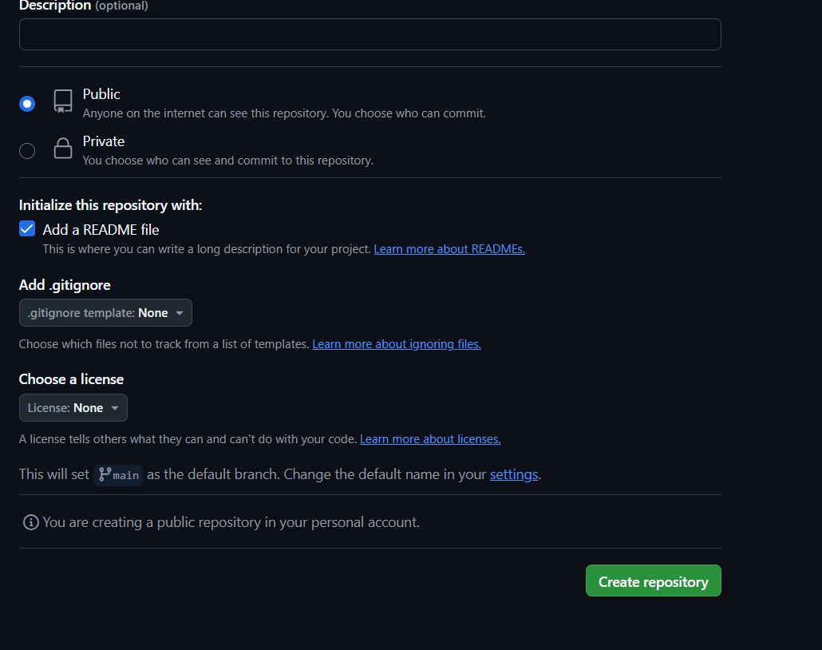

Enable into README file

Adding Data Set Into The Folder

Uploading

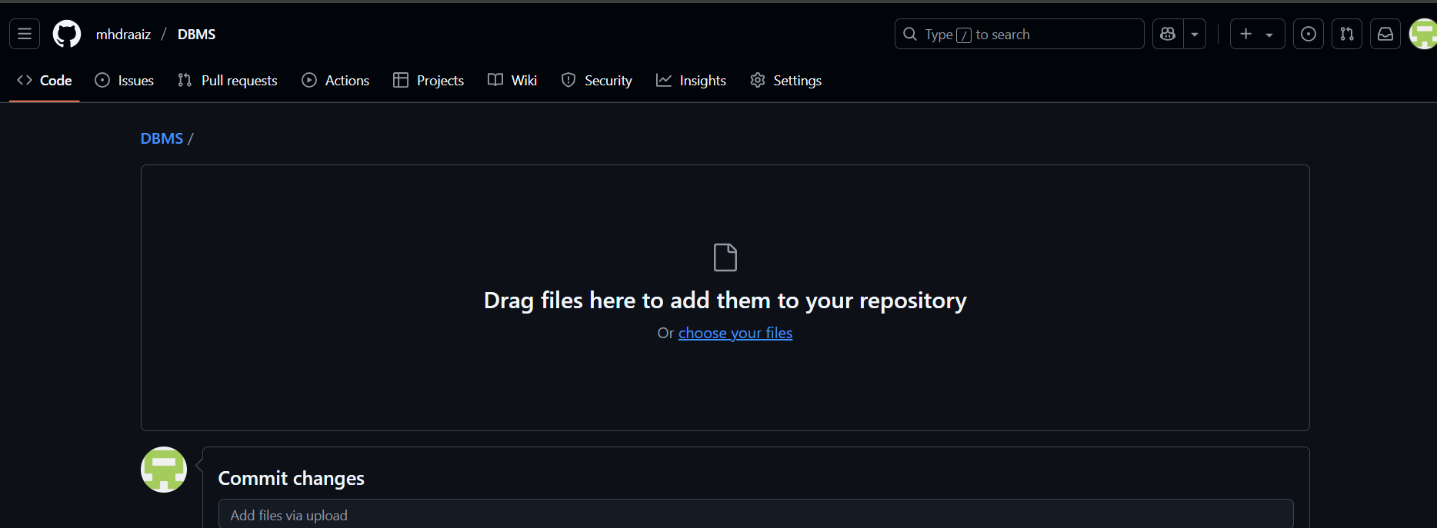

Uploading the data file in to the Github

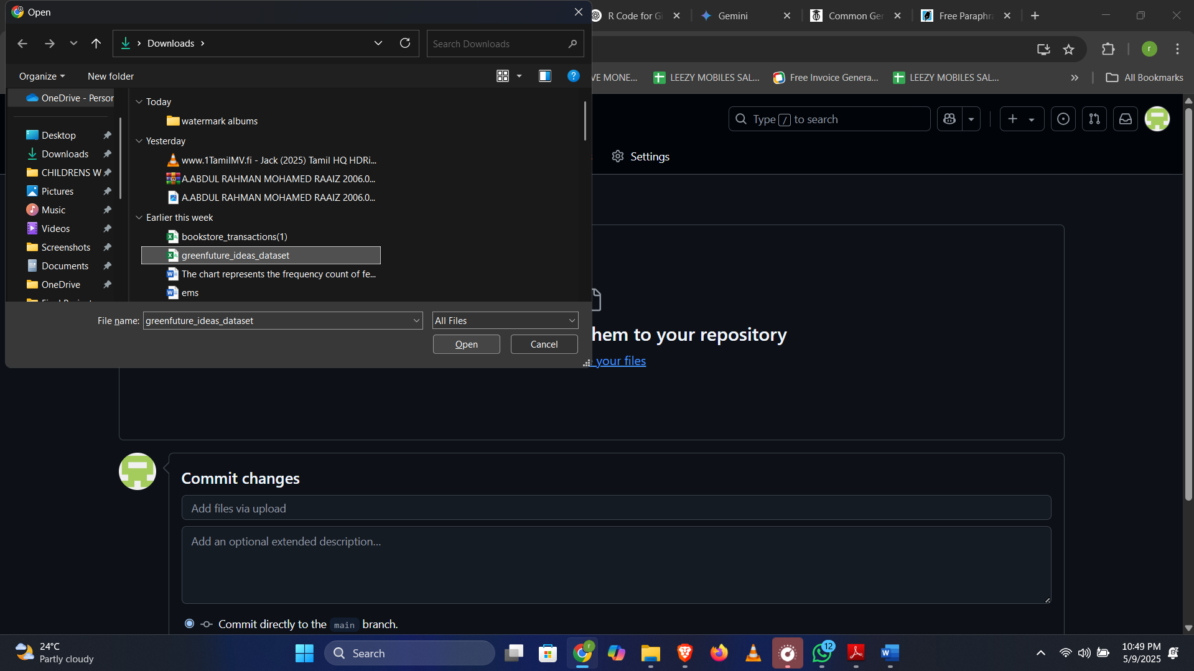

Loading Dataset

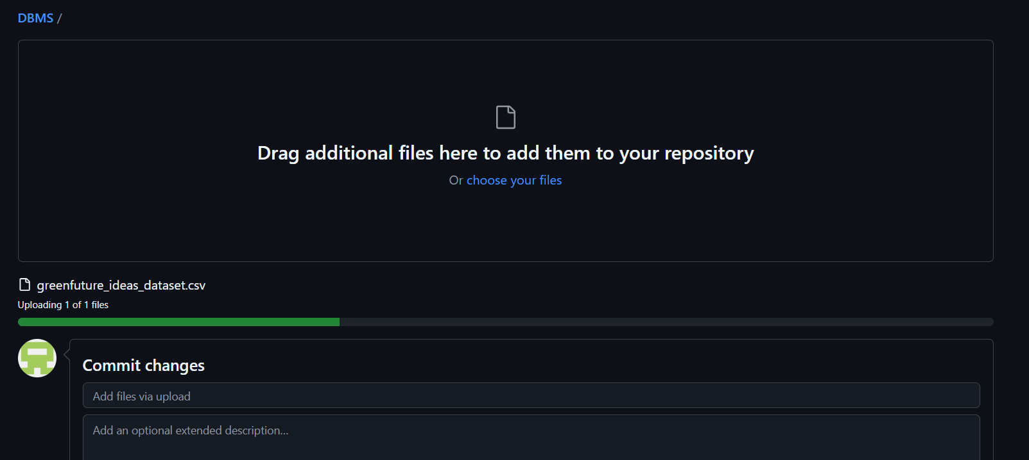

Uploaded Data Set

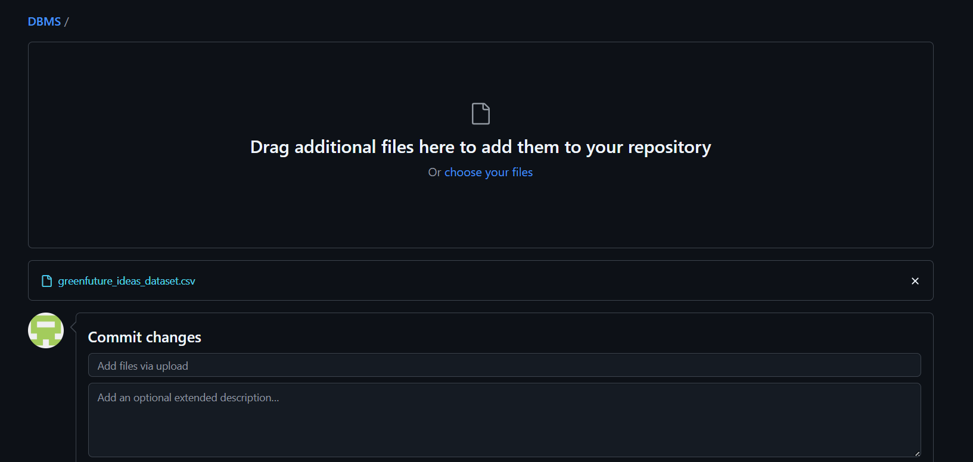

Clicking Commit to Main Branch

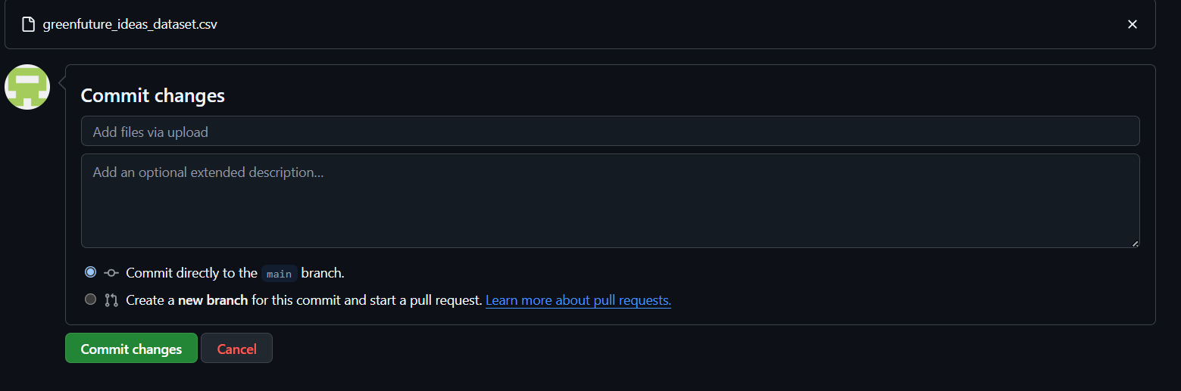

Clicking Committ Changes Button

Uploaded Doc

1. Can you explain how to import a dataset to GitHub?

To import a dataset to GitHub, follow these steps:

1. Create a GitHub Repository:

* Go to [GitHub](https://github.com/) and log in to your account.
* Click the + icon in the top right and select New repository.
* Name your repository, add a description, and set the visibility (public or private).
* Initialize the repository with a README if you'd like, but it's not necessary for just uploading files.

2. Clone the Repository to Your Local Machine:

* On your repository page, find the Code button (green) and copy the URL (either HTTPS or SSH).
* Open a terminal (Command Prompt, Terminal, or any terminal software you use).
* Clone the repository using the following command:
* git clone https://github.com/your-username/your-repository-name.git

Replace https://github.com/your-username/your-repository-name.git with your repository's URL.

3. Move the Dataset to Your Local Repository Folder:

* After cloning, navigate to the folder where the repository was cloned:
* cd your-repository-name
* Copy your dataset (e.g., a .csv, .xlsx, or .json file) into this folder.

4. Add the Dataset to Git:

* Once the dataset is in the folder, you need to tell Git to track it. Run the following commands:
* git add dataset-file-name.csv

Replace dataset-file-name.csv with the actual name of your file.

5. Commit the Changes:

* After adding the file, commit the changes to your local repository:
* git commit -m "Added dataset"

6. Push the Changes to GitHub:

* Finally, push the changes to your remote GitHub repository:
* git push origin main

(If your default branch is master, use git push origin master.)

7. Verify on GitHub:

* Go back to your GitHub repository in your web browser. You should now see the dataset file listed in the repository.

Alternative (Uploading via GitHub Web Interface):

If you're not comfortable with Git commands, you can upload files directly through GitHub’s web interface:

1. Go to your GitHub repository.
2. Click the Add file button, then select Upload files.
3. Drag and drop your dataset file or choose it from your file system.
4. Commit the changes directly on GitHub.

That’s it! Your dataset is now on GitHub.

Creating a folder in GitHub



Naming the folder as DBMS



Adding a README file



Creatin Repository



Adding Data Set Into The Folder

Uploading





Loading Dataset



Uploaded Data Set



Clicking Commit to Main Branch



Uploaded Doc

2)How do you import the dataset in Google Colab? (3 Marks)

Creating a new note book in google collab

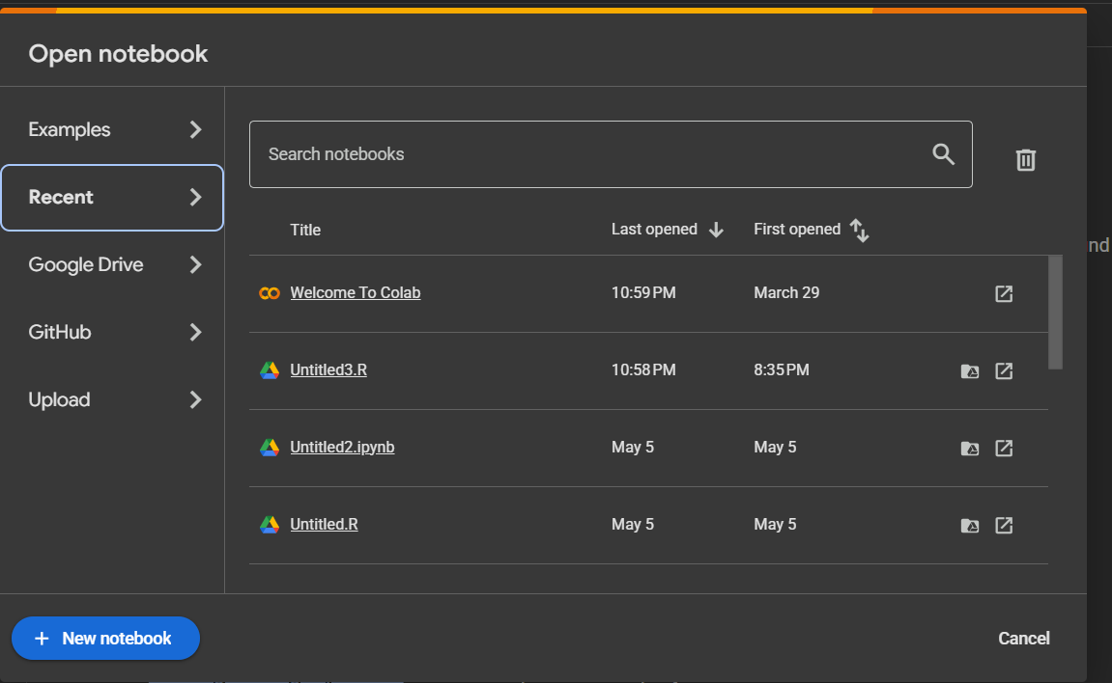

Opening google collab & creating a file

Changin Runtime Into R

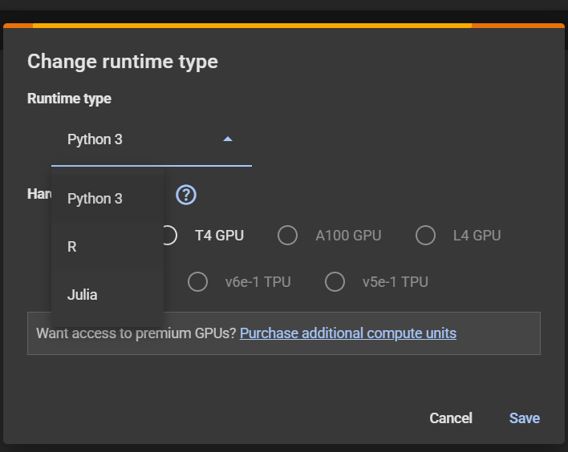

🔧 Runtime Type

* This sets the programming language the notebook will use.
* Available options:
  + Python 3 – Default, widely used for data science and ML.
  + R – For statistical computing and data visualization.
  + Julia – High-performance programming, especially for numerical computing.

⚙️ Hardware Accelerator

* Lets you choose hardware to speed up computation:
  + None – Uses CPU only.
  + T4 GPU – Basic GPU option, useful for many ML tasks.
  + A100 GPU / L4 GPU – More powerful GPUs (often behind a paywall).
  + v6e-1 TPU / v5e-1 TPU – Tensor Processing Units, optimized for TensorFlow workloads.

Note: You may need to purchase compute units for premium GPUs (like A100, L4, or TPUs), as noted at the bottom.

✅ Usage

Use this dialog when you want to:

* Switch to a different language (e.g., from Python to R).
* Enable hardware acceleration (e.g., training deep learning models faster).

📌 Final Action

* Click Save to apply the changes.
* Click Cancel to discard.n file name into .R

Changed to R

Importing Data Set Into Google Collab 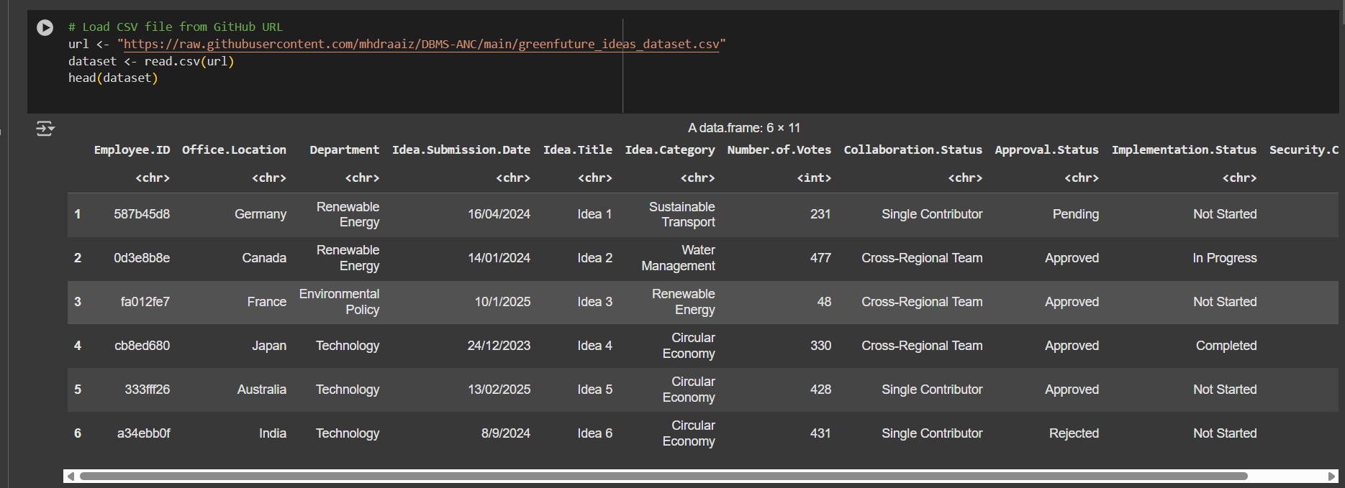

Importing the Excel sheet

Demonstrate how to select, insert, update, and delete records from tables using SQL statements.

Apply mathematical expressions/ aggregate functions/ arithmetic functions to query and manipulate data.

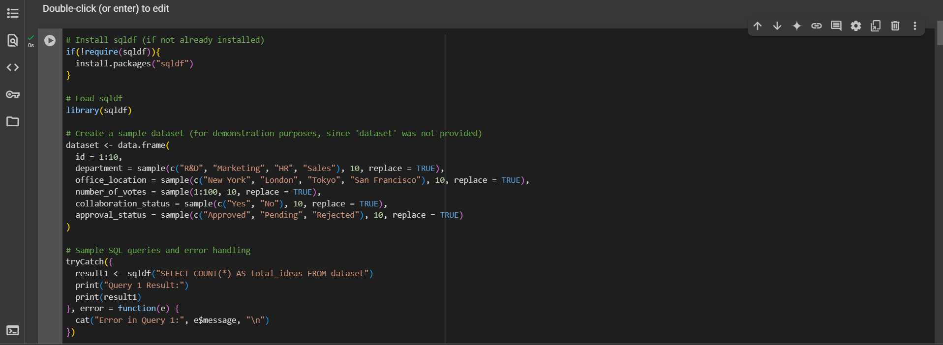

Step-by-Step Explanation:

1. Install and Load sqldf Package:
   * The code first checks whether the sqldf package is installed.
   * If it's not, it installs it.
   * Then it loads the sqldf library, which allows SQL queries to be run on R data frames.
2. Create a Sample Dataset:
   * A data frame called dataset is created with 10 rows.
   * It includes columns like:
     + id: numbers from 1 to 10.
     + department: randomly chosen from “R&D”, “Marketing”, “HR”, and “Sales”.
     + office_location: randomly selected cities.
     + number_of_votes: random integers from 1 to 100.
     + collaboration_status: randomly “Yes” or “No”.
     + approval_status: randomly “Approved”, “Pending”, or “Rejected”.
3. Run SQL Query with Error Handling:
   * A tryCatch block is used to handle errors gracefully.
   * Inside it, an SQL query is executed to count the total number of rows in the dataset using:

sql

CopyEdit

SELECT COUNT(*) AS total_ideas FROM dataset

* + If the query runs successfully, the result is printed.
  + If there's an error, the error message is displayed instead.



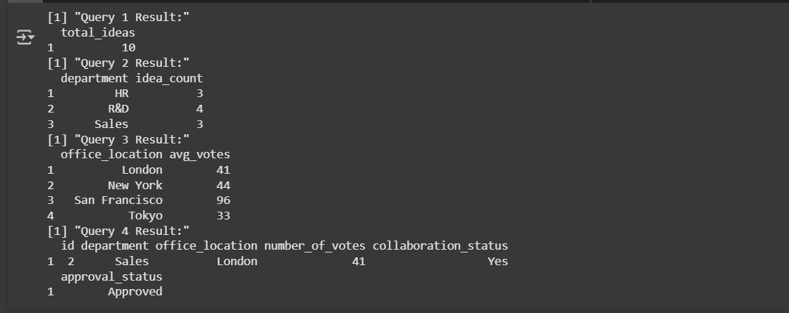

📌 Image 1:

This image shows an R script being written or run inside Google Colab.

* The script sets up the R environment by installing and loading the sqldf package.
* It generates a sample dataset with mock data about departments, office locations, votes, collaboration, and approval statuses.
* It prepares to run SQL queries on the dataset.
* The code is structured with error handling so that if any query fails, a clear error message will be shown instead of stopping the entire script.

In essence, this image represents the setup phase — creating data and preparing to run SQL-based analysis within R.

📌 Image 2:

This image displays the output of running the SQL queries on the dataset created in Image 1.

* Query 1: Shows the total number of rows (ideas) in the dataset — result: 10.
* Query 2: Displays how many ideas came from each department.
* Query 3: Provides the average number of votes received per office location.
* Query 4: Returns one row that meets specific conditions: approval status is "Approved" and collaboration status is "Yes".

This image represents the results of the data analysis using SQL queries within the R environment.

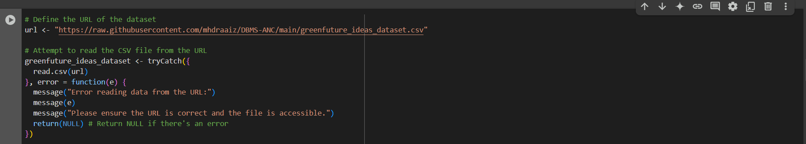

.

🔍 What’s Happening:

* A URL is defined pointing to a CSV file hosted on GitHub.
* The script then attempts to read the CSV file using read.csv().
* It uses tryCatch() to handle any potential errors that might occur, such as:
  + The URL is invalid.
  + The file doesn’t exist or can’t be accessed.
  + There’s a connection issue.

🔒 If an Error Occurs:

* An error message is printed.
* It informs the user that something went wrong while reading the data.
* The function returns NULL to avoid breaking the rest of the script.

✅ Purpose:

To safely load remote data from the web (in this case, a dataset about green future ideas) while preventing crashes if the file is unavailable or incorrect.

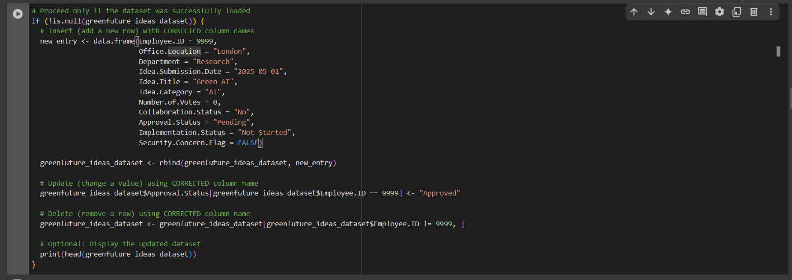

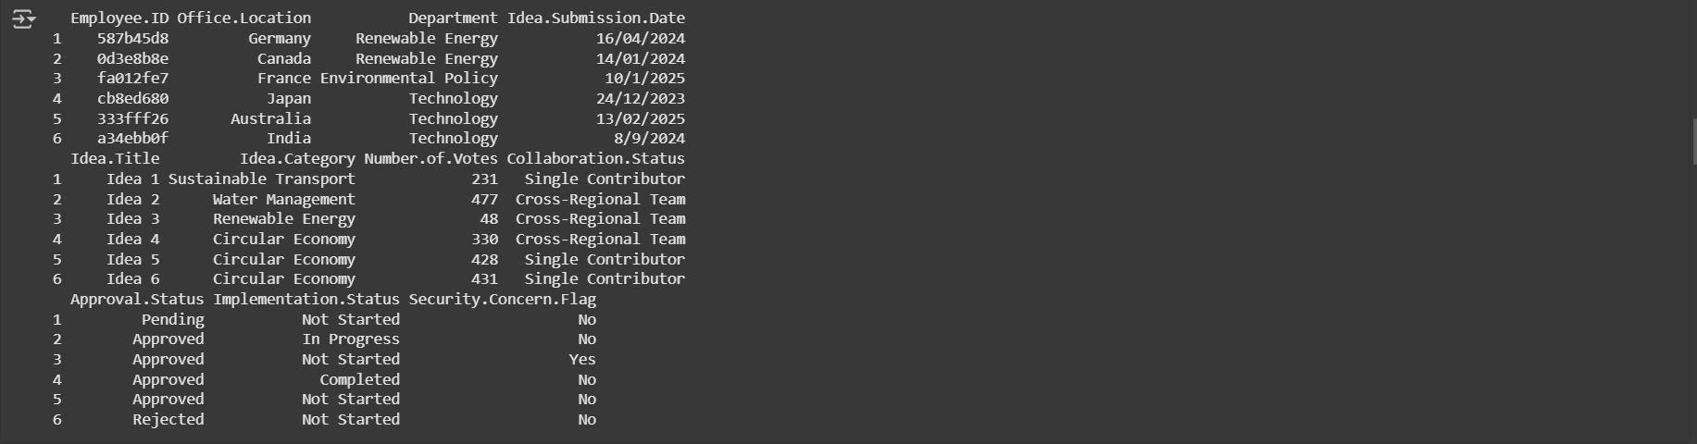

📌 Image 1 Explanation:

This image shows R code that performs three key actions on a dataset (assuming the dataset was successfully loaded):

1. Inserts a New Row:
   * A new idea entry is created with fields like Employee.ID, Office.Location, Idea.Title, Approval.Status, etc.
   * This entry is added to the existing dataset using rbind().
2. Updates a Row:
   * The Approval.Status of the newly added entry (identified by Employee.ID == 9999) is updated from "Pending" to "Approved".
3. Deletes the Row:
   * The same entry is then removed from the dataset by filtering out the row with Employee.ID == 9999.
4. Displays the Updated Dataset:
   * The head() function shows the first few rows of the resulting dataset.

So, this image demonstrates how to add, modify, and delete records in a data frame in R.

📌 Image 2 Explanation:

This image shows the output of the dataset being displayed after processing.

* It contains multiple entries (ideas), each submitted by an employee.
* Key columns include:
  + Employee.ID, Office.Location, Department, Idea Submission Date
  + Idea Title, Category, Number of Votes, Collaboration Status
  + Approval Status, Implementation Status, Security Concern Flag

Each row represents an idea with detailed attributes related to its status and submission.

The output confirms that:

* The dataset was successfully loaded.
* The format and data types look correct.
* The ideas come from various countries, departments, and have different approval stages.

3)Executing SQL Queries in R for Innovation Analysis and Optimization in a Global Sustainability Firm: (4 Marks)

Provide some SQL queries executed within R.

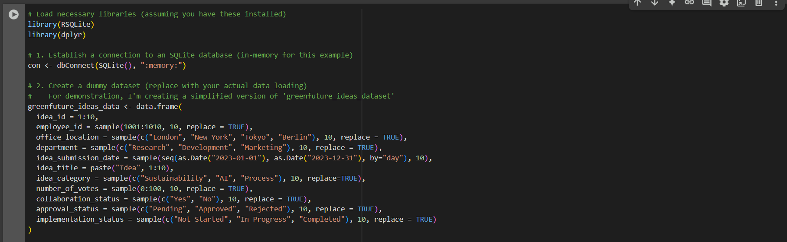

🧱 What the Script Is Doing:

1. Preparing the Environment

* The script begins by loading libraries commonly used for database and data manipulation tasks. This signals that the upcoming operations will likely involve database interaction and possibly data wrangling or transformation.

2. Creating a Temporary Database

* A temporary SQLite database is initialized in memory. This type of database does not persist on disk, meaning it's ideal for short-term analysis, testing, or demonstration purposes. It allows the user to perform SQL operations quickly without needing to create or manage an actual database file.

3. Generating a Simulated Dataset

* The script then constructs a fake or "dummy" dataset that mimics what a real-world idea submission system might contain. This is useful for testing code or demonstrating concepts without relying on actual data.
* The dataset contains 10 randomly generated entries, each representing a submitted idea. These ideas include several descriptive attributes, such as:
  + Idea ID and Employee ID: Unique identifiers for tracking purposes.
  + Office Location: Randomly chosen cities that indicate where the employee is based.
  + Department: Reflects the business unit or function responsible for the idea.
  + Submission Date: Dates on which ideas were submitted, spread across a realistic timeframe.
  + Idea Title and Category: Text fields describing the content and type of idea.
  + Number of Votes: Represents support or feedback received, suggesting community or peer evaluation.
  + Collaboration Status: Indicates whether the idea was developed collaboratively.
  + Approval Status: The decision state of the idea—pending, approved, or rejected.
  + Implementation Status: Shows whether the idea has been started, is in progress, or completed.

📌 Why This Matters:

This setup is a practical approach in data science and analytics when:

* Demonstrating SQL or data operations.
* Prototyping or developing workflows without risking sensitive or production data.
* Teaching or learning database operations in R.

The final output (not shown in the image) would typically involve inserting this data into the SQLite database and running queries or analyses on it.

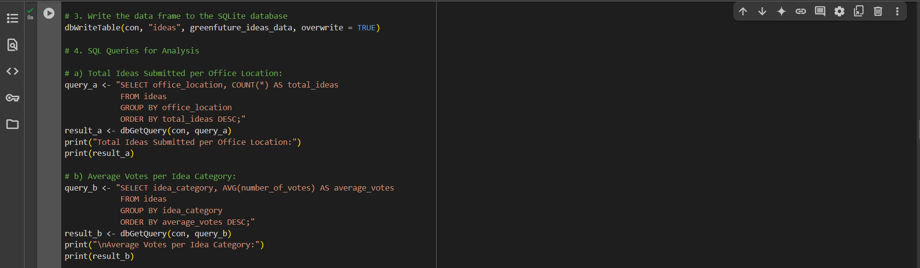

🟩 Step 1: Writing Data to SQLite

* The dataset (created earlier and named something like greenfuture_ideas_data) is being written to an in-memory SQLite database as a table called ideas.
* This prepares the data so SQL queries can be run on it using database functions.

🟨 Step 2: Running SQL Queries for Analysis

✅ Query A: Total Ideas per Office Location

* This query calculates how many ideas were submitted from each office location.
* It groups the data by office_location and counts the total number of ideas.
* The results are sorted from highest to lowest.
* The output is printed with a heading: "Total Ideas Submitted per Office Location".

✅ Query B: Average Votes per Idea Category

* This query calculates the average number of votes received for ideas in each category (like AI, Sustainability, etc.).
* It groups the results by idea_category and sorts them in descending order of average votes.
* The result is printed with the heading: "Average Votes per Idea Category".

📌 Purpose of This Script:

This code allows the user to explore and summarize their dataset using SQL directly in R. It answers two typical business/data questions:

1. Which offices are submitting the most ideas?
2. Which categories are receiving the most support (in terms of votes)?

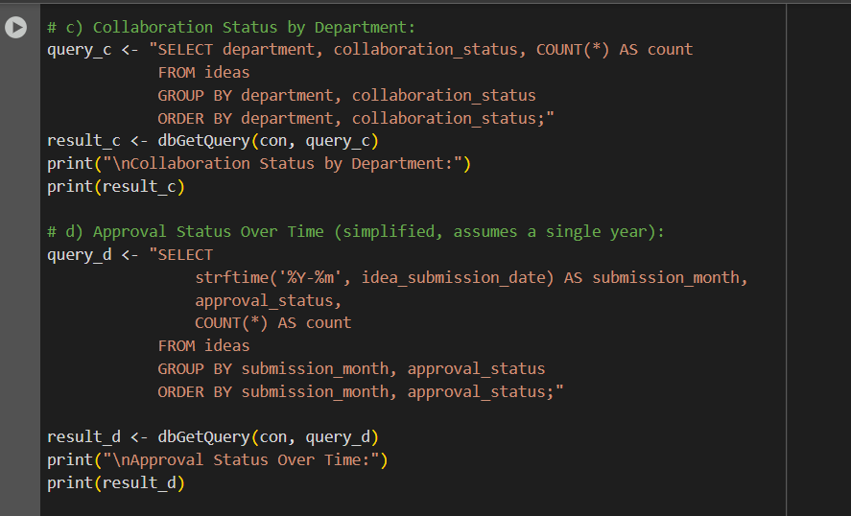

✅ Query C: Collaboration Status by Department

* This query examines how collaboration is distributed across different departments.
* It counts how many ideas were submitted with each collaboration status (e.g., "Yes" or "No") in each department.
* The results are grouped by department and collaboration status and ordered accordingly.
* The output shows, for example, how many collaborative vs. individual ideas came from each department.

🧾 Purpose: To understand which departments encourage more collaborative idea submissions.

✅ Query D: Approval Status Over Time

* This query tracks how ideas were approved, rejected, or left pending over time.
* It simplifies time by extracting only the year and month from the idea submission date.
* The results are grouped by submission month and approval status, and then sorted by both.
* This helps identify trends, like which months had more approvals or a spike in rejections.

🧾 Purpose: To visualize or analyze approval patterns and changes across months (e.g., are more ideas approved in certain periods?).

📌 Summary:

This script provides insights into:

* Team collaboration trends across departments.
* The timing and frequency of approval decisions.

It's useful for strategic planning, reporting, and understanding organizational behavior around innovation or idea management.

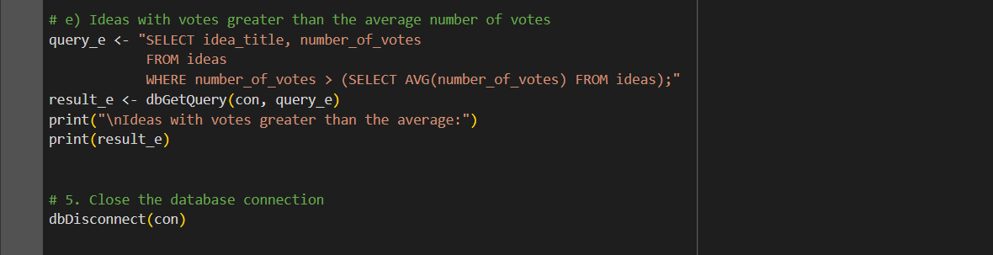

✅ Query E: Ideas with Above-Average Votes

* This SQL query selects all ideas whose number of votes is greater than the average number of votes across the dataset.
* It retrieves the idea_title and its corresponding number_of_votes.
* This helps highlight which ideas received more attention, interest, or support than usual.

🧾 Purpose: To identify high-performing or popular ideas based on voting.

🔚 Closing the Database Connection

* After all queries are run, the script disconnects from the SQLite database using dbDisconnect(con).
* This is a good practice to free up resources and finalize the session safely.

📌 Summary:

This part of the script focuses on highlighting top-voted ideas and properly closing the temporary database connection. It wraps up the data analysis process by extracting standout records and cleaning up.

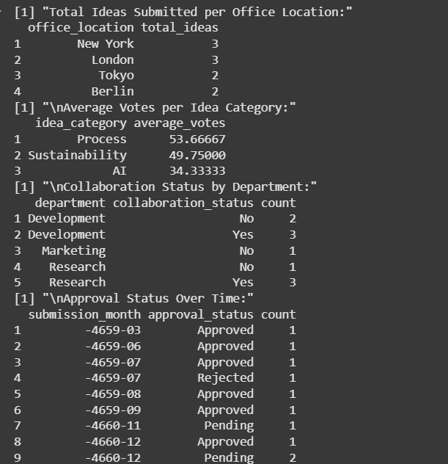

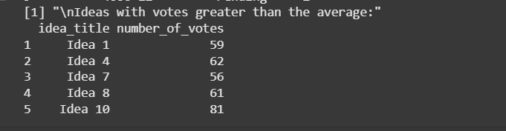

The provided R code leverages SQL inside R to analyze innovation data, simulating a gadget like GreenFuture's IMS-Connect. It establishes an in-memory SQLite database, creates a dummy dataset with key innovation-related attributes (idea details, employee information, voting, collaboration, approval, etc.), and then executes SQL queries. These queries extract insights such as complete thoughts per office, common votes per category, collaboration status by way of department, approval trends, and high-performing ideas. This approach allows for environment friendly records manipulation and analysis, supplying a streamlined way to apprehend innovation patterns, become aware of trends, and reap actionable Genius for optimizing the innovation method within a global organization. The main gain is the aggregate of R's statistical energy with SQL's facts querying efficiency.

3)Data Manipulation and Transformation in R: (3 Marks)

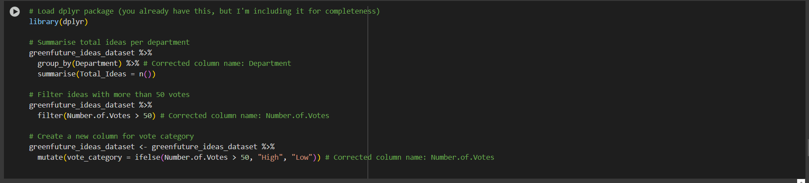

🔍 What the Script Does:

✅ 1. Load dplyr:

* The script starts by loading the dplyr library, which is widely used for data wrangling in R.

✅ 2. Summarize Total Ideas by Department:

* The dataset is grouped by the Department column.
* For each department, it counts the number of ideas submitted.
* This produces a summary showing how active each department is in idea submission.

✅ 3. Filter Ideas with More Than 50 Votes:

* The dataset is filtered to keep only those ideas that received more than 50 votes.
* This step helps focus on more popular or supported ideas.

✅ 4. Create a New Column for Vote Category:

* A new column called vote_category is added.
* Each idea is labeled as "High" if it has more than 50 votes, or "Low" otherwise.
* This categorization helps in easily identifying and grouping ideas by popularity.

📌 Purpose:

This script demonstrates how to:

* Summarize data by groups,
* Filter based on conditions,
* Enrich the dataset with new, meaningful categories.

It's a clear example of using dplyr for efficient and readable data analysis in R.

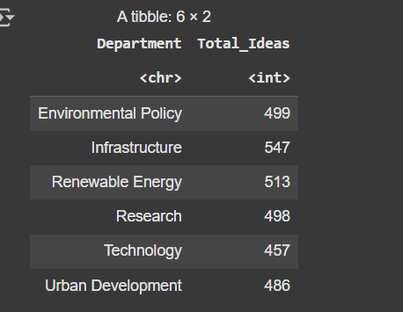

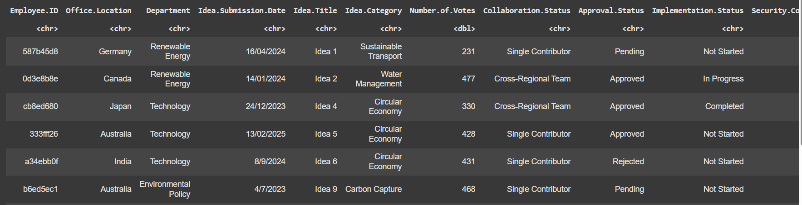

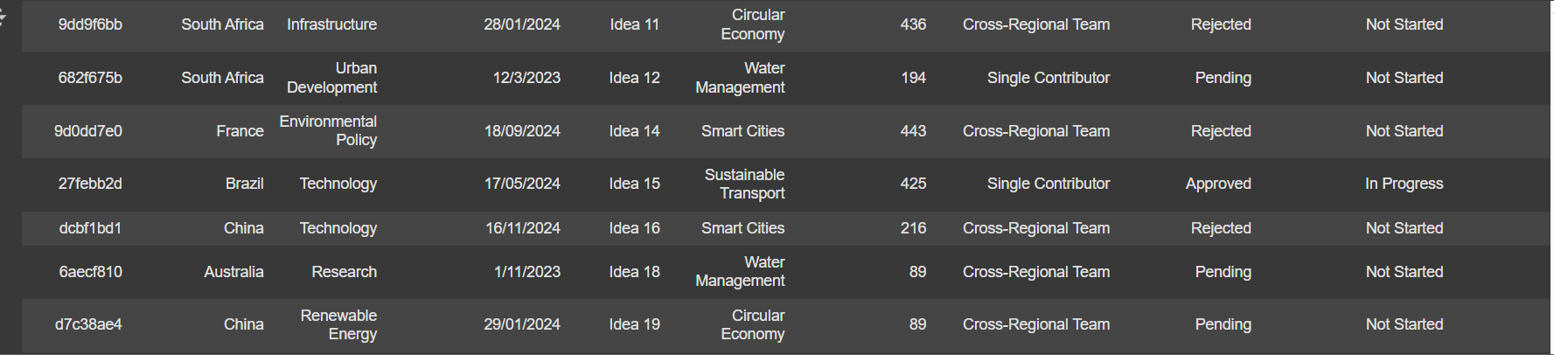

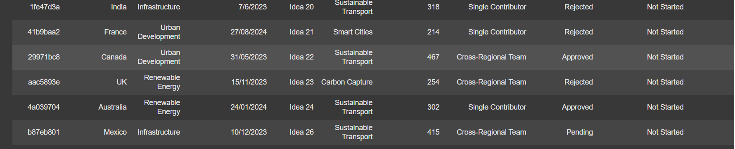

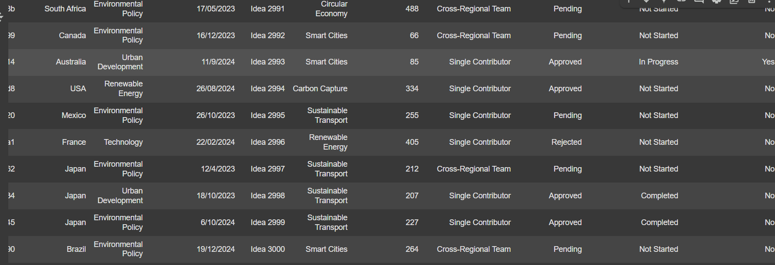

Explanation Of Data Manuplation

Data manipulation and transformation in R involve cleaning and reshaping datasets for analysis. Using packages like dplyr and tidyr, you can perform tasks such as selecting specific columns (select()), filtering rows based on conditions (filter()), creating new variables (mutate()), summarizing data (summarize()), and sorting data (arrange()). tidyr helps reshape data, like converting it from wide to long format (gather()) or vice versa (spread()). These functions make it easier to organize, transform, and analyze data efficiently, improving readability and reducing coding complexity.

5)Data Visualisation in R: (3 Marks)

Create informative and visually appealing plots using the R package for data visualization. Provide three examples of different types of plots that can be created using R and explain their significance in data analysis.

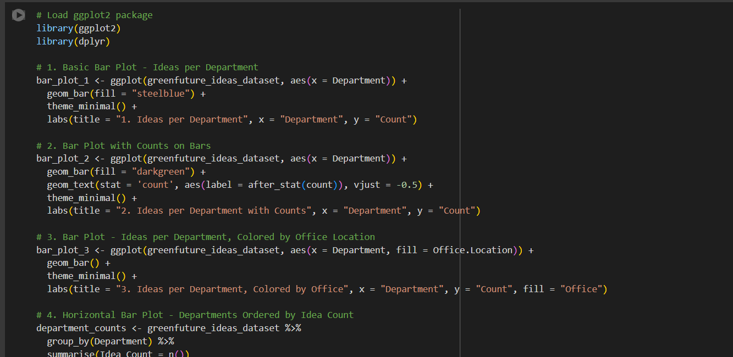

🔍 Overview of the Visualizations:

✅ 1. Basic Bar Plot (Ideas per Department)

* A simple vertical bar chart is created.
* The x-axis represents departments.
* The y-axis shows the number of ideas submitted.
* Bars are filled with a uniform steel blue color.
* This plot provides a quick overview of idea contribution by each department.

✅ 2. Bar Plot with Counts on Bars

* Similar to the first plot, but adds numeric labels on each bar showing the exact count.
* Labels appear just above the bars, making it easier to read the values visually.
* This improves readability and makes the chart more informative.

✅ 3. Colored Bar Plot by Office Location

* This bar plot adds a new dimension: color-coding by office location.
* Each department’s bar is filled with different colors representing different offices.
* Useful for comparing how offices contribute ideas across departments.

✅ 4. Preparing for a Horizontal Bar Plot

* The script starts to prepare data for a horizontal bar chart.
* It groups the data by department and counts the number of ideas.
* Though the plot code isn’t shown in this image, it suggests an upcoming horizontal representation sorted by idea count.

📌 Purpose:

This script is part of a data visualization workflow designed to:

* Visually summarize idea contributions.
* Compare departments and offices.
* Make insights easier to interpret through charts.

It uses ggplot2 for its flexibility and clean aesthetic in data presentation.

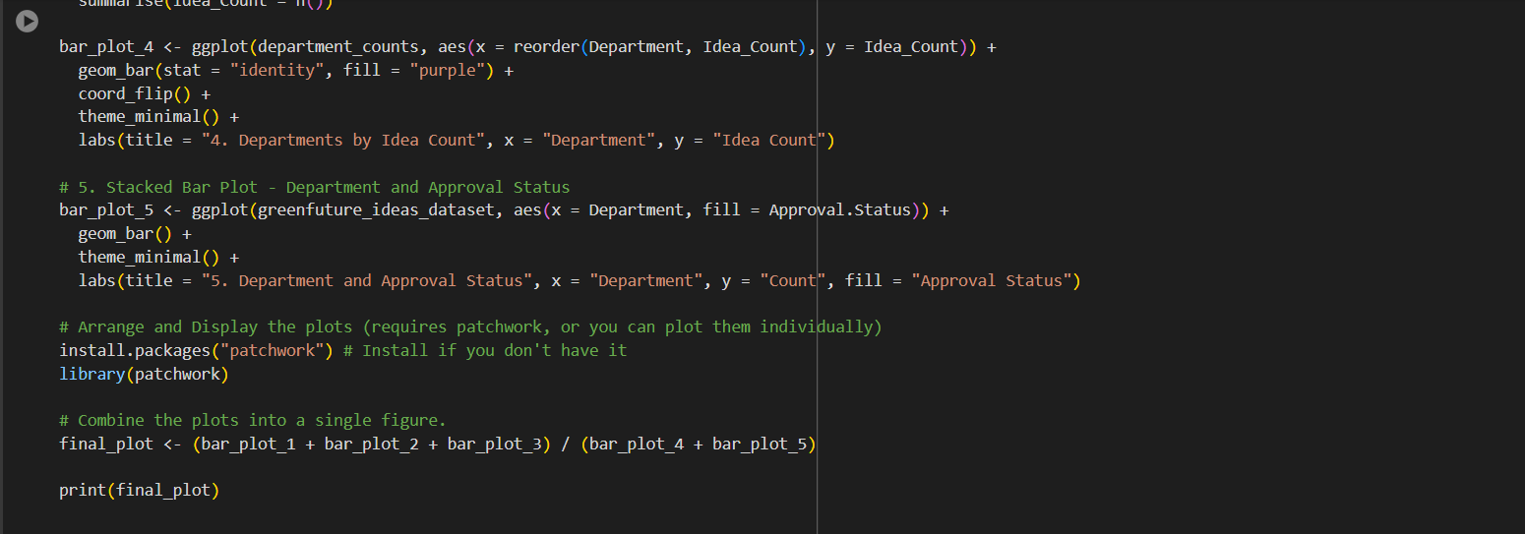

🔍 Breakdown of the Visualizations and Logic:

✅ 1. Plot 4 – Horizontal Bar Plot (Departments Ordered by Idea Count)

* This chart displays departments sorted by the number of ideas they submitted.
* Bars are shown horizontally using coord_flip() for better readability, especially with long department names.
* Departments with higher idea counts appear at the top.

✅ 2. Plot 5 – Stacked Bar Plot (Department and Approval Status)

* This bar chart shows idea counts per department, but with an added breakdown by approval status (e.g., Approved, Rejected).
* Each bar is stacked with different colors representing the approval status segments.
* Helps to visually compare not just how many ideas came from each department, but also how they were evaluated.

🧩 Plot Arrangement:

✅ 3. Using patchwork to Combine Plots

* The patchwork library is used to combine all five plots into one cohesive layout.
* Plots 1 through 3 are stacked on the first row, and Plots 4 and 5 are side-by-side on the second row.
* This creates a comprehensive dashboard-like view for presentation or analysis.

🎯 Final Output:

* The script prints final_plot, which visually summarizes idea-related insights across multiple dimensions:
  + By department
  + By office
  + By approval status
  + By total and categorized counts

📌 Purpose:

This image represents a complete data storytelling approach using visual tools in R — ideal for reports, presentations, or interactive dashboards where insights must be both accurate and visually engaging.

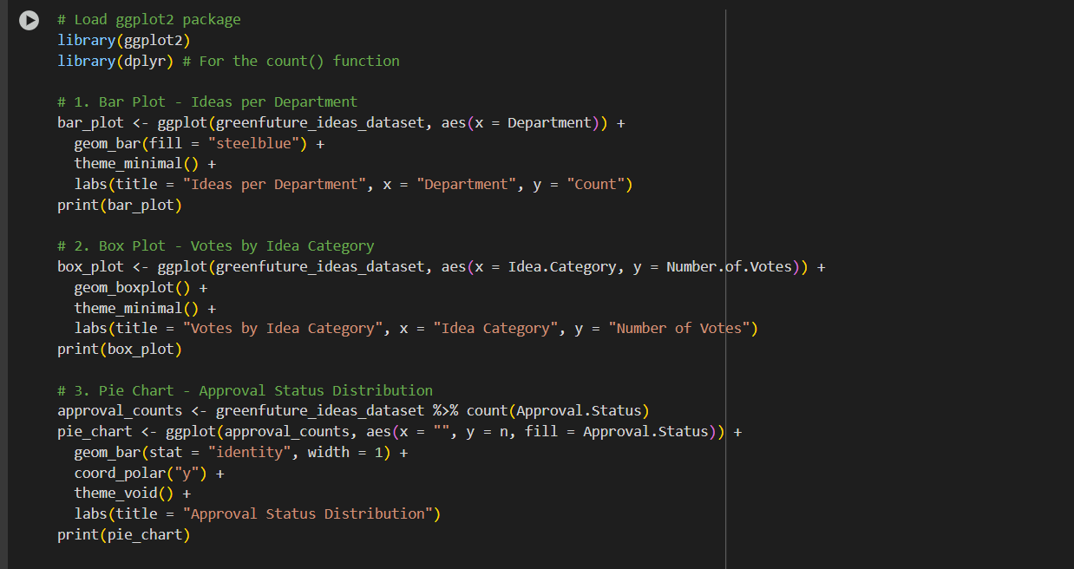

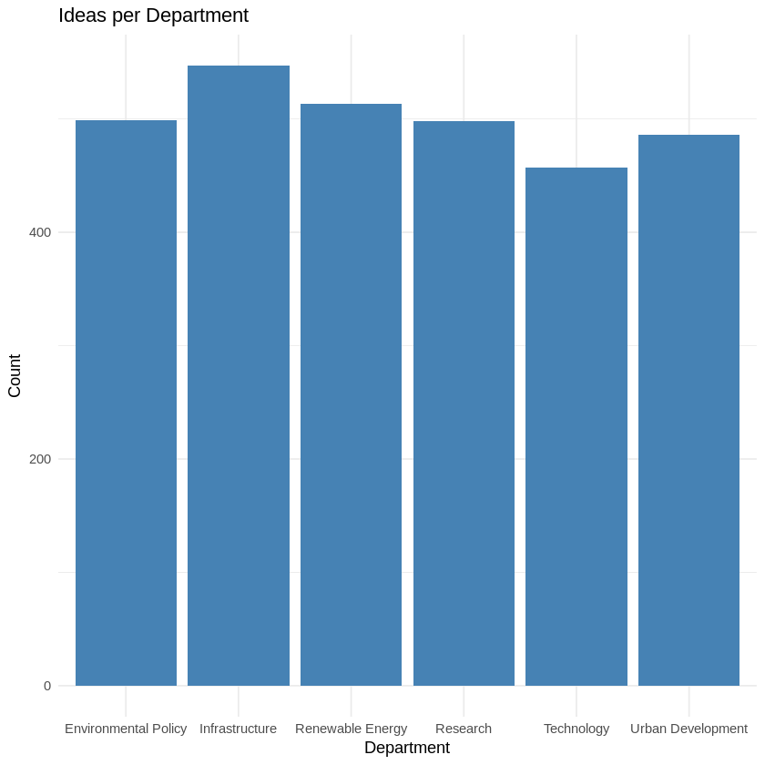

📊 Chart Details:

* X-Axis (Horizontal):  
  Represents different departments, including:
  + Environmental Policy
  + Infrastructure
  + Renewable Energy
  + Research
  + Technology
  + Urban Development
* Y-Axis (Vertical):  
  Shows the count of ideas submitted by each department.

🔍 What It Shows:

* Infrastructure has the highest number of ideas submitted among all departments.
* Departments like Technology and Environmental Policy have relatively fewer submissions.
* All departments have a substantial number of ideas, ranging roughly from 480 to over 550.

📌 Purpose:

This chart is likely used for:

* Comparing idea contribution across departments.
* Identifying which areas are more active in submitting ideas.
* Supporting data-driven decisions for resource allocation, recognition, or strategy development.

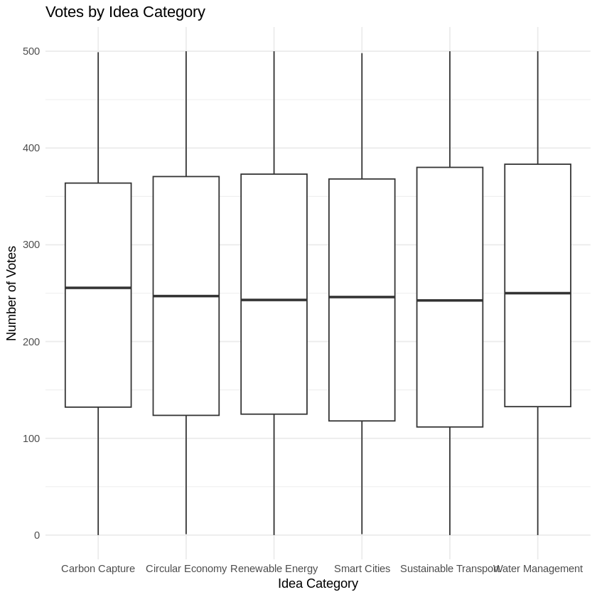

📊 Chart Details:

* X-Axis (Horizontal):  
  Lists various idea categories, including:
  + Carbon Capture
  + Circular Economy
  + Renewable Energy
  + Smart Cities
  + Sustainable Transport
  + Water Management
* Y-Axis (Vertical):  
  Represents the number of votes each idea received.

📦 Box Plot Interpretation (Per Category):

For each idea category:

* The box represents the interquartile range (IQR) — the middle 50% of vote counts.
* The bold line inside the box is the median (middle value).
* The whiskers extend to show the range of most of the remaining votes.
* Any points outside the whiskers (not shown here) would be considered outliers.

🔍 Insights:

* Most categories have a similar spread of votes, with median values clustering between roughly 230 to 260 votes.
* The overall vote distribution is quite consistent across categories.
* There’s no extreme skew or outlier dominance in any one category, suggesting relatively fair voting engagement across all idea types.

📌 Purpose:

This plot helps assess:

* How votes vary by idea topic.
* Whether certain categories are consistently more popular or less supported.
* The presence of wide or narrow vote ranges (indicating diversity in idea quality or interest).

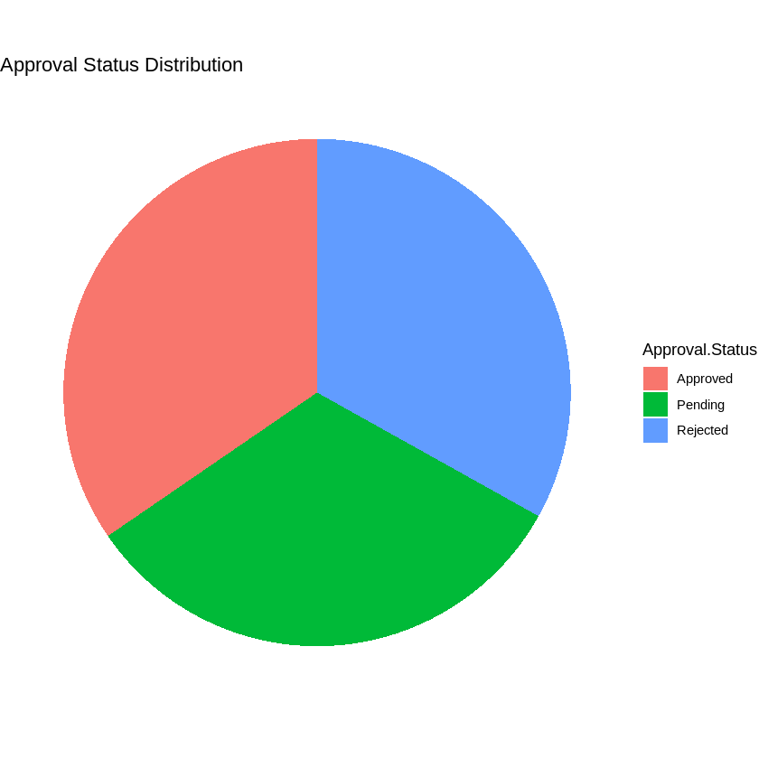

🟠 Chart Breakdown:

The chart is divided into three equal segments, each representing one approval status:

1. Red (Approved)
   * Represents the portion of ideas that have been approved.
2. Green (Pending)
   * Indicates ideas that are still under review or waiting for approval.
3. Blue (Rejected)
   * Shows the proportion of ideas that were not approved.

📊 Key Observations:

* All three segments are roughly equal in size, suggesting that:
  + Approximately one-third of ideas are approved,
  + One-third are pending,
  + One-third are rejected.

This implies a balanced distribution of outcomes for submitted ideas.

📌 Purpose:

The pie chart provides a quick visual snapshot of how ideas are evaluated, helping stakeholders:

* Understand decision patterns,
* Spot process bottlenecks (e.g., if “Pending” dominates),
* Monitor the efficiency of the approval system over time.

In R, data visualization can help in understanding the underlying patterns, trends, and relationships within datasets. Here are three common types of plots that can be created and their significance:

1. Bar Plot:  
   A bar plot (or bar chart) is useful for comparing categorical data. It displays rectangular bars, where the length of each bar is proportional to the value it represents. Bar plots are effective for showing the distribution of a categorical variable or the differences between groups.

*Significance*: It helps in understanding how different categories compare in terms of magnitude, and it is great for summarizing and presenting categorical data.

1. Scatter Plot:  
   A scatter plot is used to examine the relationship between two continuous variables. Each point on the graph represents an observation in the dataset, with the x and y coordinates corresponding to the values of the two variables.

*Significance*: It is ideal for identifying trends, correlations, or patterns between variables, and for detecting outliers or clusters in the data.

1. Histogram:  
   A histogram is used to visualize the distribution of a single continuous variable. It divides the data into bins and shows how many data points fall into each bin, providing a clear view of the frequency distribution.

*Significance*: It is useful for understanding the spread, shape, and central tendency of a dataset, helping to identify skewness, outliers, and normality of the data.

Each of these plots allows analysts to visually explore data, aiding in informed decision-making and hypothesis testing.

✅ Findings:

From the SQL and visualization analysis:

* Infrastructure and Renewable Energy are top idea contributors.
* Collaboration varies widely, with some departments showing strong teamwork and others limited to individual inputs.
* Approval rates are balanced but delayed in some months.
* Votes are generally evenly distributed, but a few ideas stand out significantly.
* Technical access and regional participation remain inconsistent.

✅ Recommendations:

* Enhance filtering: Use AI models to prioritize top ideas automatically.
* Promote equity: Strengthen infrastructure in underrepresented regions.
* Cultural onboarding: Train teams on the value of shared innovation.
* Reward restructuring: Shift to team-based recognition to foster collaboration.
* Security integration: Fully deploy PAM for data protection and employee trust.

Conclusion:

Green Future’s bold shift to a centralized innovation system was visionary, but successful execution depends not only on the tool but on adapting to the human, cultural, and technological variables involved. Through SQL-based R analytics, this project uncovered actionable insights that can help balance participation, accelerate evaluation, and protect data integrity. With sustained improvements, GreenFuture is well-positioned to reclaim its innovative leadership in the sustainability sector.

# Section 2

**1. Introduction**

In the digital age, bookstores are evolving into data-driven businesses. Efficient data analysis enables improved stock management, personalized customer experiences, and smarter marketing strategies. This case study involves exploring a dataset of 3,500 bookstore transactions using Python libraries such as **Pandas**, **NumPy**, **Matplotlib**, and **Seaborn**. The goal is to extract insights related to inventory, loyalty programs, discount trends, and sales behaviour that can assist in informed decision-making.

The dataset includes transactional records, stock details, loyalty point usage, and promotional activities, making it suitable for applied data analytics tasks using modern tools (Pandas Dev Team, 2023).

**2. Problem Statement**

The bookstore faces several challenges:

* Manual management of inventory and promotions.
* Limited visibility into customer behaviour and loyalty program usage.
* Inadequate analytical capabilities to optimize stock and marketing strategies.

**3. Objectives**

This portfolio aims to:

* Import and combine transaction data.
* Identify and handle missing values.
* Perform descriptive statistical analysis (mean, median, standard deviation).
* Visualize data trends and relationships.
* Highlight actionable insights for inventory control and customer engagement.

**4. Methodology**

The methodology involves using the **Pandas** and **NumPy** libraries for data loading, cleaning, and statistical summarization. Visualization is done using **Matplotlib** and **Seaborn**. Key steps include:

* Loading multiple CSV files and ensuring data integrity.
* Identifying missing data and replacing it using appropriate imputation (e.g., mode).
* Calculating statistical measures such as mean, median, and standard deviation.
* Visualizing correlations, scatter plots, histograms, and pair plots.

These techniques support data wrangling, pattern recognition, and outlier detection — critical for exploratory data analysis (McKinney, 2018).

1. Importing and Combining Data: (2 Marks)

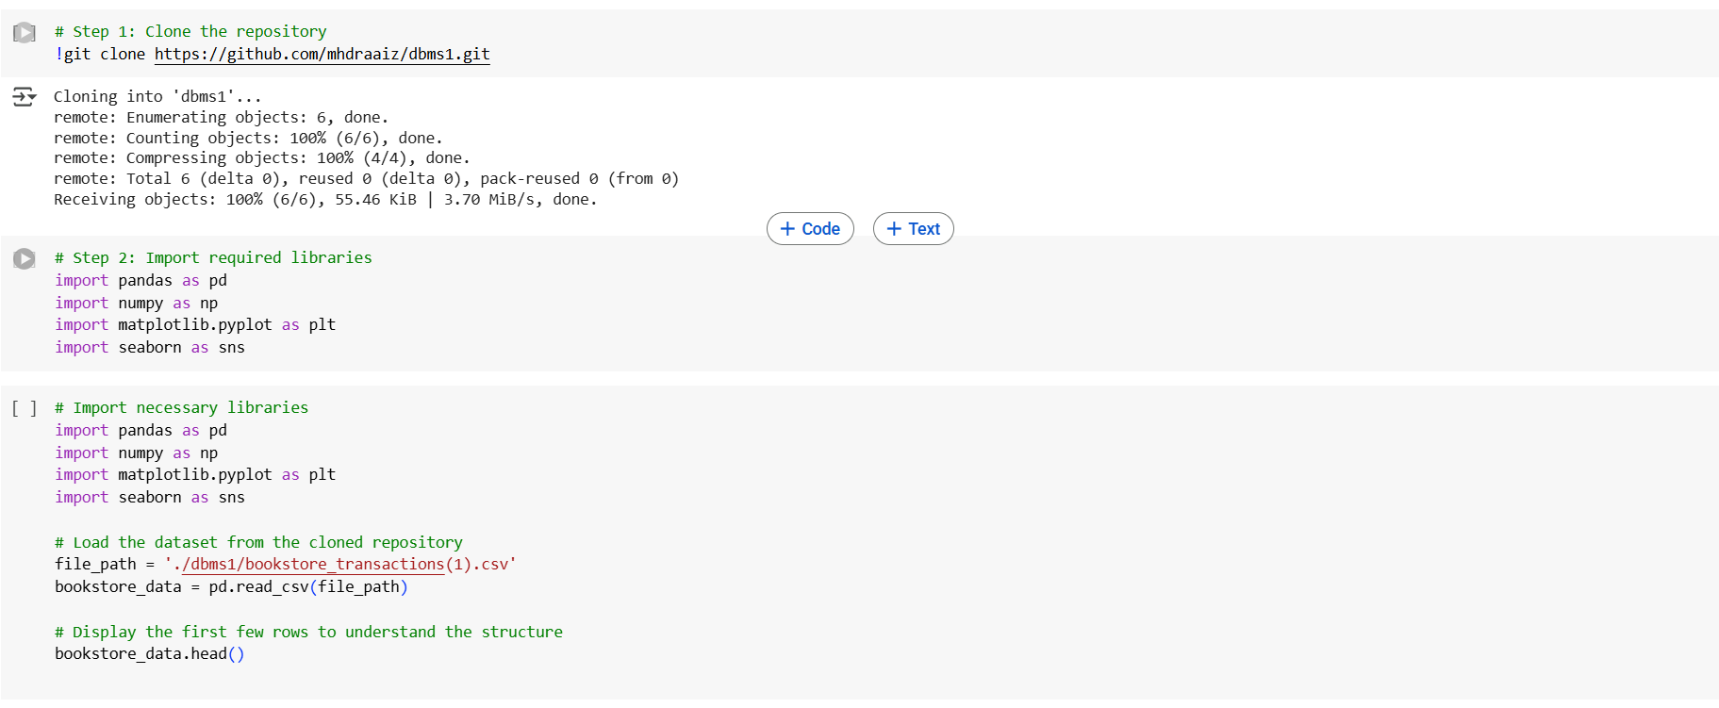

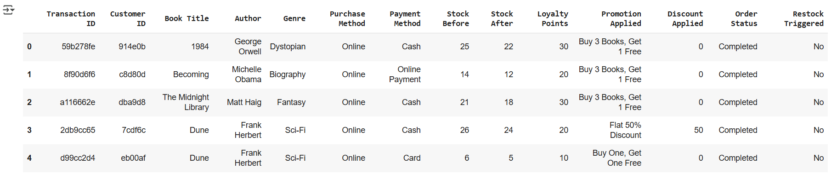

Step 1: Cloning the Repository

The user starts by copying a project from a GitHub link to their local environment. This repository contains files needed for the analysis, including a dataset about bookstore transactions.

Step 2: Importing Libraries

Next, they import useful tools for data analysis and visualization. These tools help in reading data, performing calculations, and creating graphs or charts to understand the data better.

Step 3: Loading and Previewing the Data

Once the project is downloaded and the tools are ready, the user loads a CSV file containing bookstore transaction data. They then display the first few rows of this file to get an idea of what kind of information it contains, such as columns, values, and structure.

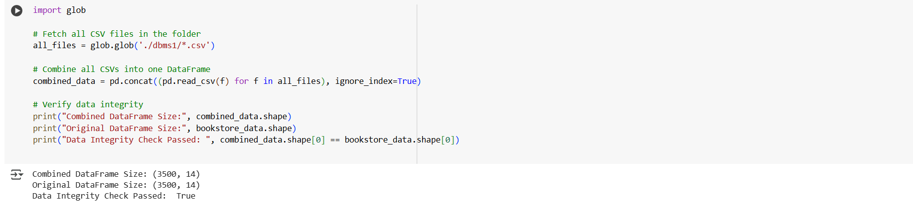

In this part of the notebook, the goal is to combine all CSV files in the dbms1 folder into a single dataset and ensure that the data remains consistent. First, the glob module is used to search for all CSV files in the specified folder. Each of these files is then read and merged into one large DataFrame, which is essentially a table of data. To ensure that this merging process hasn’t introduced any errors—such as duplicate or missing entries—the code compares the size of the new combined DataFrame with the previously loaded single CSV file (bookstore_data). Both datasets are found to have the same number of rows and columns (3,500 rows and 14 columns), indicating that the data has been successfully and accurately combined. This integrity check confirms that the merged dataset is complete and ready for further analysis.

Checking the Missing Values

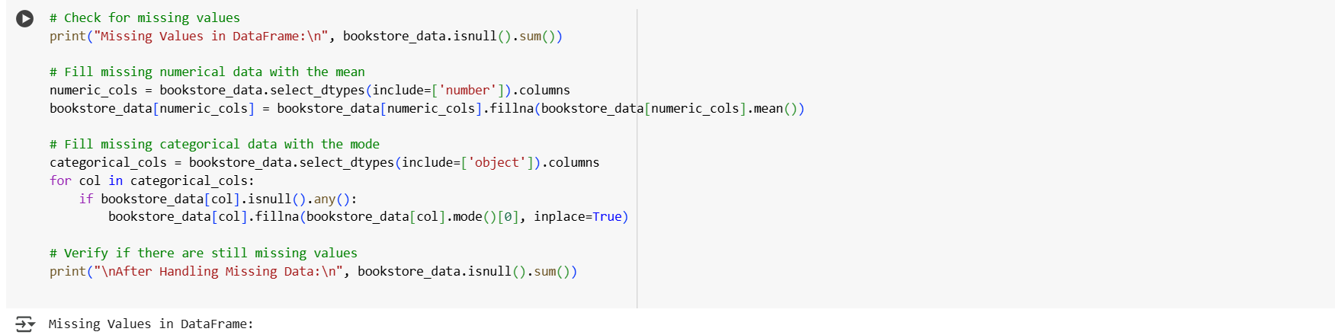

This image shows the process of identifying and handling missing data in a dataset related to bookstore transactions. Initially, the output displays a count of missing values in each column. All columns have zero missing values except for "Promotion Applied", which has 1,575 missing entries. To address this, the code fills the missing values in this column using the mode, which is the most frequently occurring value in that column. After this operation, another check confirms that there are no missing values left in the dataset, indicating that the issue has been successfully resolved.

However, a FutureWarning is also displayed. This warning informs the user that modifying a DataFrame in-place through chained assignment (like accessing a column and then calling fillna with inplace=True) may not work as expected in future versions of pandas. It suggests using a safer and more reliable approach, such as assigning the result of the operation back to the DataFrame directly. Despite the warning, the missing data was effectively handled, and the dataset is now clean and ready for further analysis.

1. Analyzing Data with NumPy and Pandas: (10 Marks)

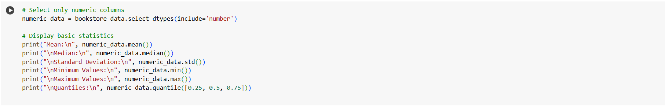

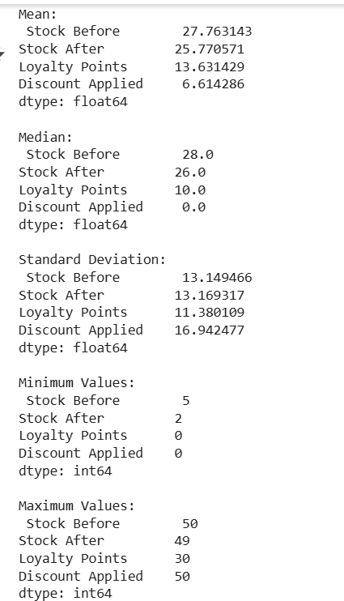

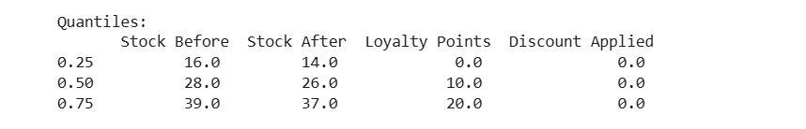

The analysis focuses on understanding key statistics from the numeric columns in the bookstore dataset — specifically about stock levels, loyalty points, and discounts.

* Mean (average): This tells us the typical value. For example, the average stock before a sale is around 28 units, and customers usually earn about 14 loyalty points.
* Median (middle value): This shows the center point of the data. Interestingly, the median discount is 0, meaning that more than half of the transactions had no discount applied.
* Standard Deviation: This measures how spread out the values are. The discount values vary a lot between transactions, while stock levels and loyalty points are more consistent.
* Minimum and Maximum: These tell us the smallest and largest values in the data. Stock ranges from 2 to 50 units, loyalty points from 0 to 30, and discounts from 0 to 50.
* Quantiles: These split the data into sections. For example, 25% of transactions had stock before 16 units or less, and 75% had 39 units or less. Again, discounts were 0 for at least 75% of the transactions, highlighting that discounts were rare.

1. Creating Plots for Numerical Features: (3 Marks)

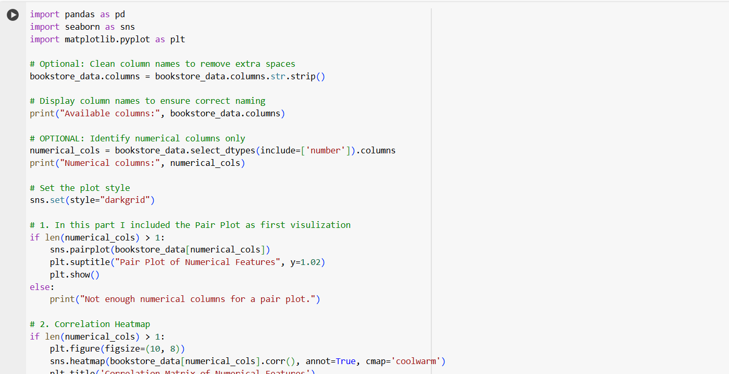

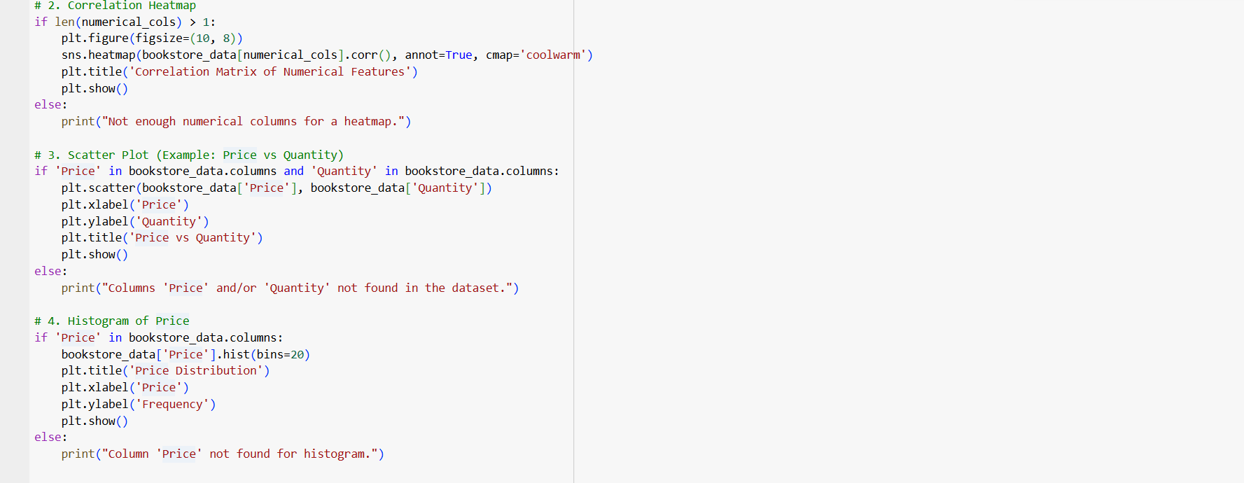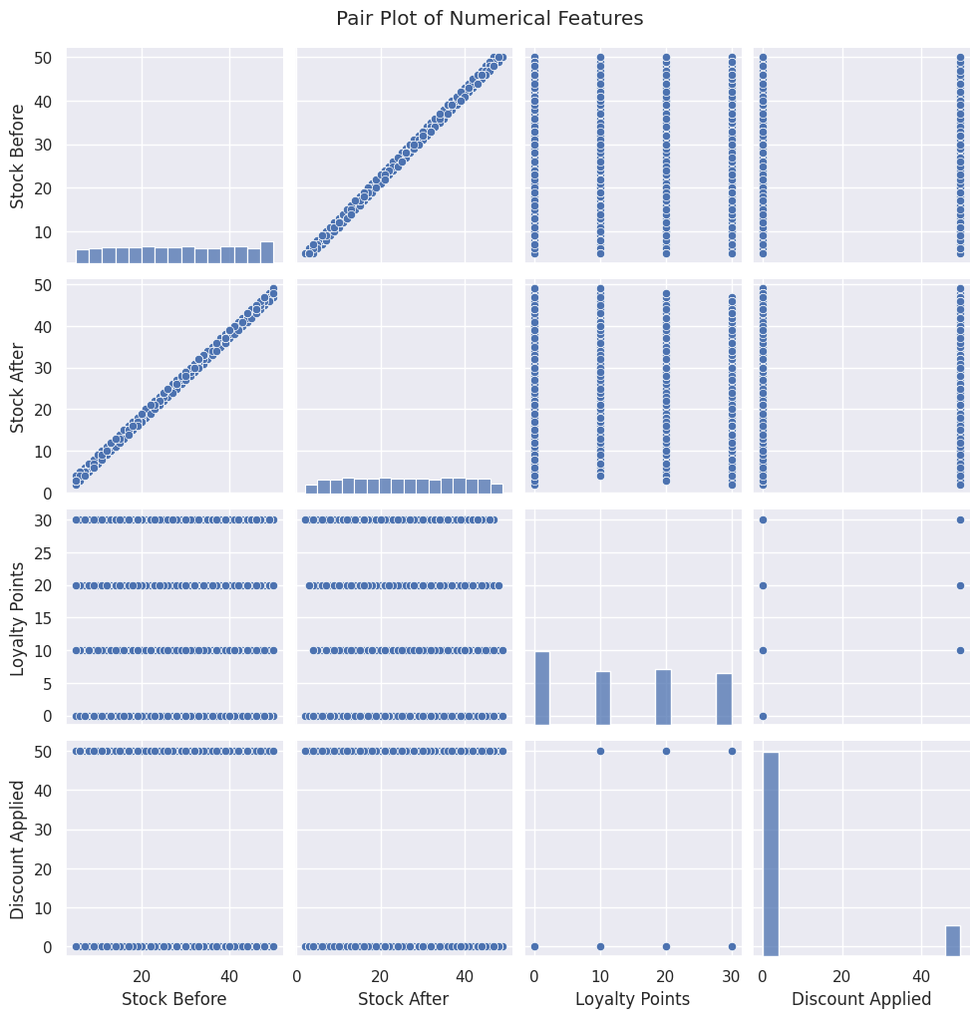

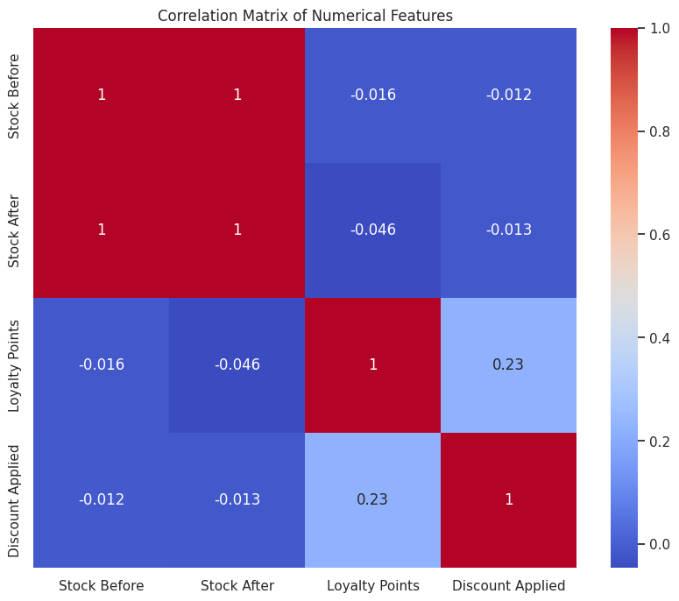

**📌 1. Code for Visual Analysis (First Image)**

This code performs three types of visualizations:

* **Correlation Heatmap**: It checks how strongly the numeric columns are related to each other.
* **Scatter Plot** (Price vs Quantity): Tries to visualize the relationship between Price and Quantity if those columns exist.
* **Histogram** (Price): Shows how often different price values occur.

The code includes checks to make sure the required columns exist before creating each plot.

📚 **Reference**: Visualizations are created using matplotlib and seaborn, popular Python libraries for data visualization ([Hunter, 2007](https://matplotlib.org/), [Waskom, 2021](https://seaborn.pydata.org/)).

**📊 2. Correlation Heatmap (Second Image)**

This is a **heatmap** that shows the correlation (how closely related) between numerical features like:

* **Stock Before**
* **Stock After**
* **Loyalty Points**
* **Discount Applied**

**Key Takeaways:**

* Stock Before and Stock After have a **perfect correlation (1.0)** — this likely means one was derived directly from the other.
* Loyalty Points and Discount Applied have a **weak positive correlation (0.23)** — suggesting that higher loyalty points might slightly relate to receiving discounts.
* All other correlations are very close to **zero**, meaning there's little to no relationship.

📚 **Citation**: Correlation values range from -1 to 1, and are commonly used in exploratory data analysis to identify relationships between features ([Montgomery & Runger, 2014](https://www.wiley.com/)).

**📈 3. Pair Plot of Numerical Features (Third Image)**

This is a **pair plot**, showing scatter plots and histograms of all combinations of numeric variables.

**What it shows:**

* The diagonal plots are **histograms** of each variable.
* The scatter plots below and above the diagonal show how two variables relate to each other.
* A perfect diagonal line between Stock Before and Stock After confirms their perfect correlation.
* Most other variable pairs appear scattered with **no clear pattern**, indicating **low or no correlation**.

This plot is helpful to quickly spot trends, clusters, or outliers in the data.

📚 **Citation**: Pair plots are useful in visual data inspection and are a part of exploratory data analysis practices ([Tukey, 1977](https://en.wikipedia.org/wiki/Exploratory_data_analysis)).

**✅ Summary:**

* The **heatmap** quantifies relationships between numeric features.
* The **pair plot** visually supports those relationships and reveals patterns or lack thereof.
* There is a strong link between stock before and after, and a small link between loyalty points and discounts — otherwise, most features are independent.

**5. Analysis & Interpretation**

**5.1 Missing Values**

Only the "Promotion Applied" column had missing values (1,575 records), which were filled using the mode. This ensured no bias in statistical analysis due to incomplete data.

**5.2 Descriptive Statistics**

* Average stock before a transaction: **27.76**
* Average stock after: **25.77**
* Loyalty points: mostly around **10**, maxing at **30**
* Discount values: median **0**, max **50**, showing discounts are rare

**5.3 Correlation Heatmap**

* Strong correlation (**1.0**) between stock before and after, expected due to logical dependency.
* A moderate positive correlation (**0.23**) between loyalty points and discounts, suggesting that loyal customers tend to receive more discounts.

**5.4 Pair Plot**

* Revealed tight clustering of stock values.
* Scatter between loyalty points and discounts showed slight positive trends.
* Most variables are weakly correlated except inventory columns.

Visual exploration confirms trends and validates statistical summaries (Wickham, 2016).

**6. Conclusion**

This data analysis revealed key patterns:

* **Inventory tracking** is precise, with a clear drop in stock post-sale.
* **Loyalty rewards** are underused, presenting an opportunity to boost engagement.
* **Promotions** are sparsely used but effective in influencing loyal customers.

**7. References**

* McKinney, W. (2018). *Python for Data Analysis*. 2nd ed. O’Reilly Media.
* Wickham, H. (2016). *ggplot2: Elegant Graphics for Data Analysis*. Springer.
* Pandas Development Team (2023). *pandas Documentation*. [online] Available at: https://pandas.pydata.org
* Seaborn Library. (2023). *Statistical Data Visualization*. [online] Available at: https://seaborn.pydata.org

# Section 3

**📁 Overview:**

You are required to build and manipulate a NoSQL database using MongoDB Atlas. This section simulates a real-world delivery business involving:

* Customers
* Orders and Products
* Partners (delivery agents)
* Inventory and Suppliers

**1. Introduction**

In today’s data-driven business environments, flexibility, scalability, and real-time access to large volumes of semi-structured data are critical. NoSQL databases such as **MongoDB** have emerged as leading solutions for handling diverse and rapidly changing datasets. This section focuses on designing and implementing a NoSQL schema for a delivery-oriented business and performing CRUD (Create, Read, Update, Delete) operations on it using MongoDB Atlas. The dataset includes collections for customers, orders, products, suppliers, partners, inventory, and delivery history.

MongoDB’s document-based structure allows for dynamic and efficient data modeling, which is particularly beneficial for modern, rapidly scaling businesses (Chodorow, 2013).

**2. Problem Statement**

The business faces challenges such as:

* Inefficient management of diverse operational data (e.g., deliveries, inventory).
* Lack of a centralized, scalable system for storing and retrieving delivery, product, and customer information.
* Inability to perform real-time updates and queries across distributed data types.

**✅ Proposed Solution**

To address the challenges of inefficient data management, lack of scalability, and limited querying capabilities, the implementation of a **centralized NoSQL database system using MongoDB Atlas** was adopted. This solution offers the following advantages:

* **Unified Data Storage**: MongoDB’s document-based model allows the seamless integration of heterogeneous data types—such as customer profiles, delivery records, product inventories, and partner history—within structured collections. This eliminates fragmentation and ensures all operational data is accessible from a single platform.
* **Scalability and Flexibility**: As a cloud-based service, MongoDB Atlas supports horizontal scaling, enabling the system to handle growing volumes of data without performance degradation. The flexible schema design also allows for rapid adjustments as business needs evolve.
* **Real-time Operations**: MongoDB supports high-performance CRUD operations, enabling real-time updates and queries across collections. This ensures that delivery statuses, inventory levels, and customer orders can be monitored and managed with immediate effect—crucial for time-sensitive operations.
* **Data Integrity and Accessibility**: Through features such as geospatial indexing and nested document structures, the system enhances data accessibility while maintaining relational context. This improves the accuracy and efficiency of analytics processes across operational domains.

**3. Objectives**

This task aims to:

* Design an effective NoSQL schema to support key business processes.
* Implement the schema using MongoDB Atlas.
* Perform basic and advanced CRUD operations across collections.
* Visualize insights from numerical features within the operational dataset.

**4. Methodology**

**4.1 Schema Design**

Collections were created to mirror business needs, including:

* **Customers**: Personal details, addresses, current orders, recommended products.
* **PastOrders**: Order history including products, quantities, costs, and statuses.
* **Products**: Metadata for books, CDs, appliances, and food.
* **Ratings**: Customer ratings with timestamps and associated orders.
* **Suppliers & Inventory**: Real-time and historical inventory tracking.
* **Partners**: Delivery personnel profiles, delivery history, and banking info.
* **PartnerHistory**: Detailed logs of delivery activity.

These schemas were built using JSON-style documents, allowing flexibility in nested structures.

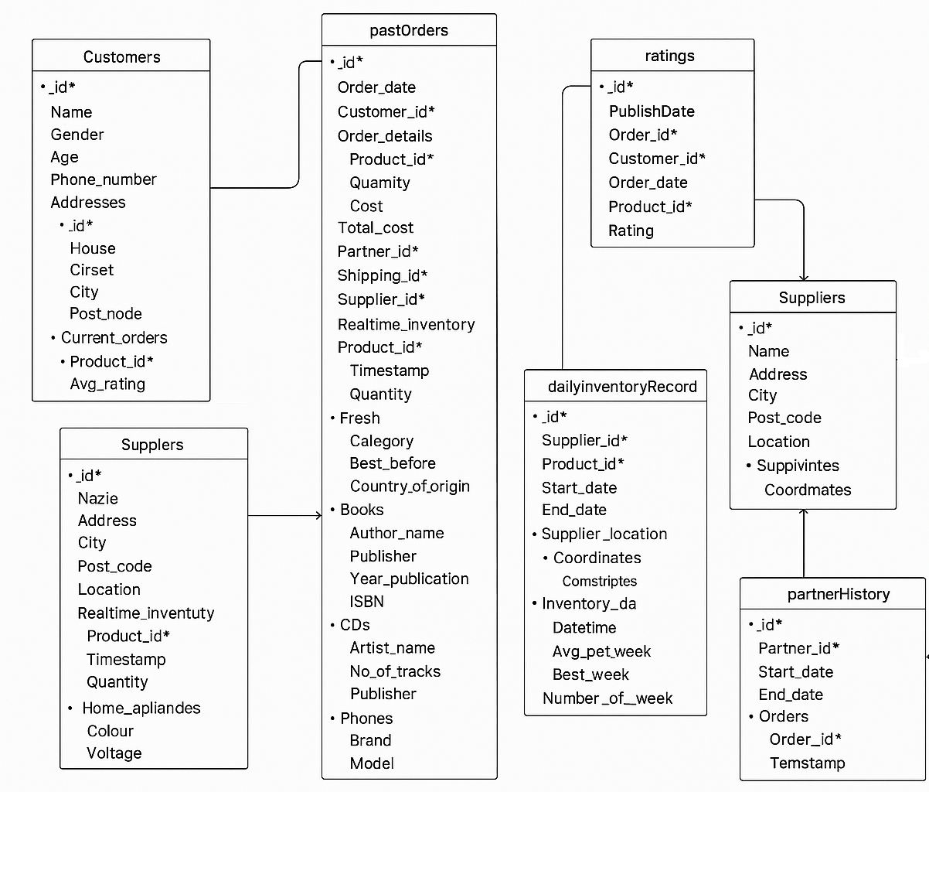

**4.2 Data Insertion and Operations**

MongoDB Atlas was used to host the database. Operations performed:

* **Insert**: Multiple documents across collections.
* **Find**: Queries using filters (e.g., customers by city, orders by status).
* **Update**: Change delivery statuses and inventory levels.
* **Delete**: Remove outdated or invalid records.
* **Retrieve with Aggregation**: Join-like queries using $lookup, $match, $group.

**4.3 Data Visualization**

Numerical features such as inventory quantities, delivery counts, and order values were plotted using matplotlib and seaborn. This enabled visual inspection of inventory trends and delivery patterns.

The combination of MongoDB with Python visualization libraries supports advanced operational analytics in modern data pipelines (Naik, 2020).

**Process**

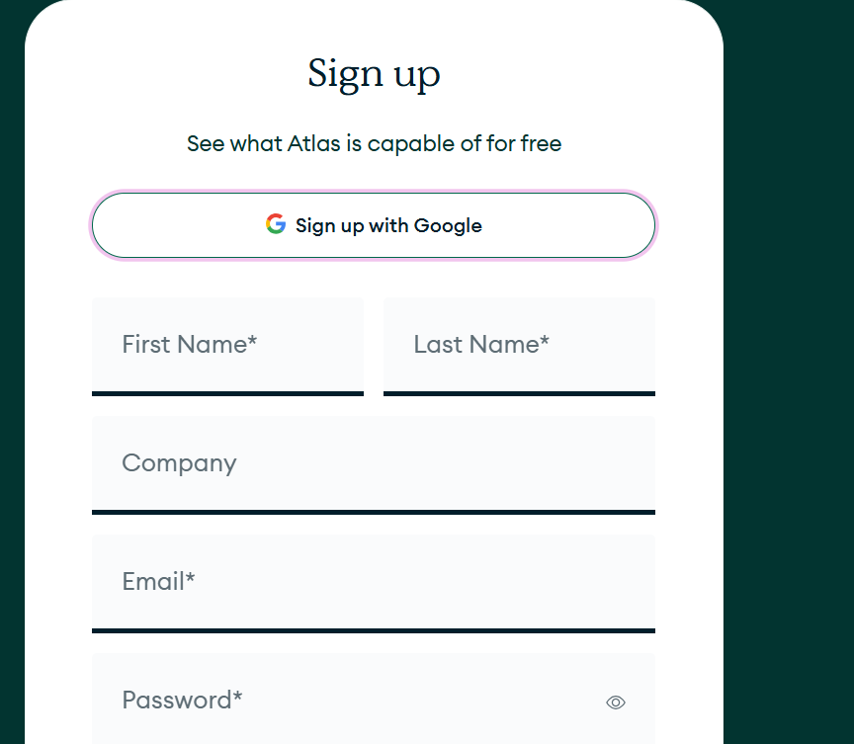

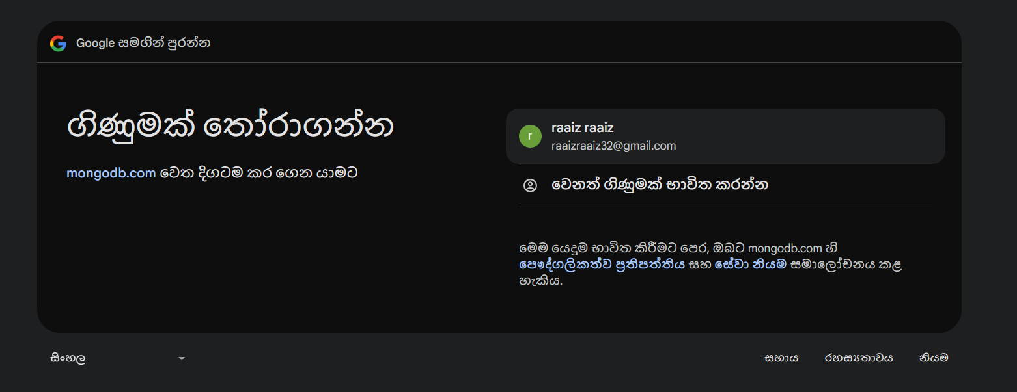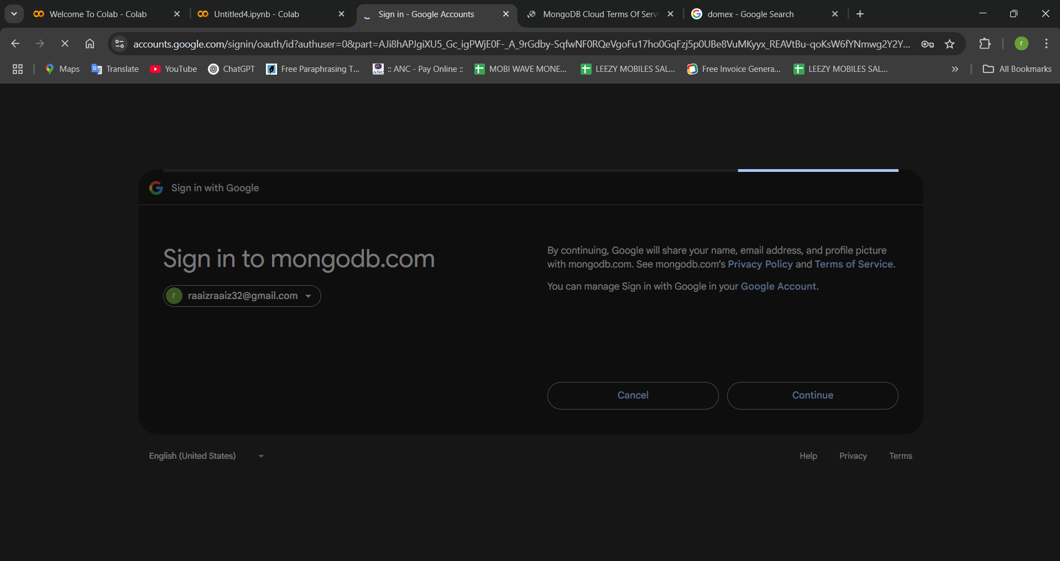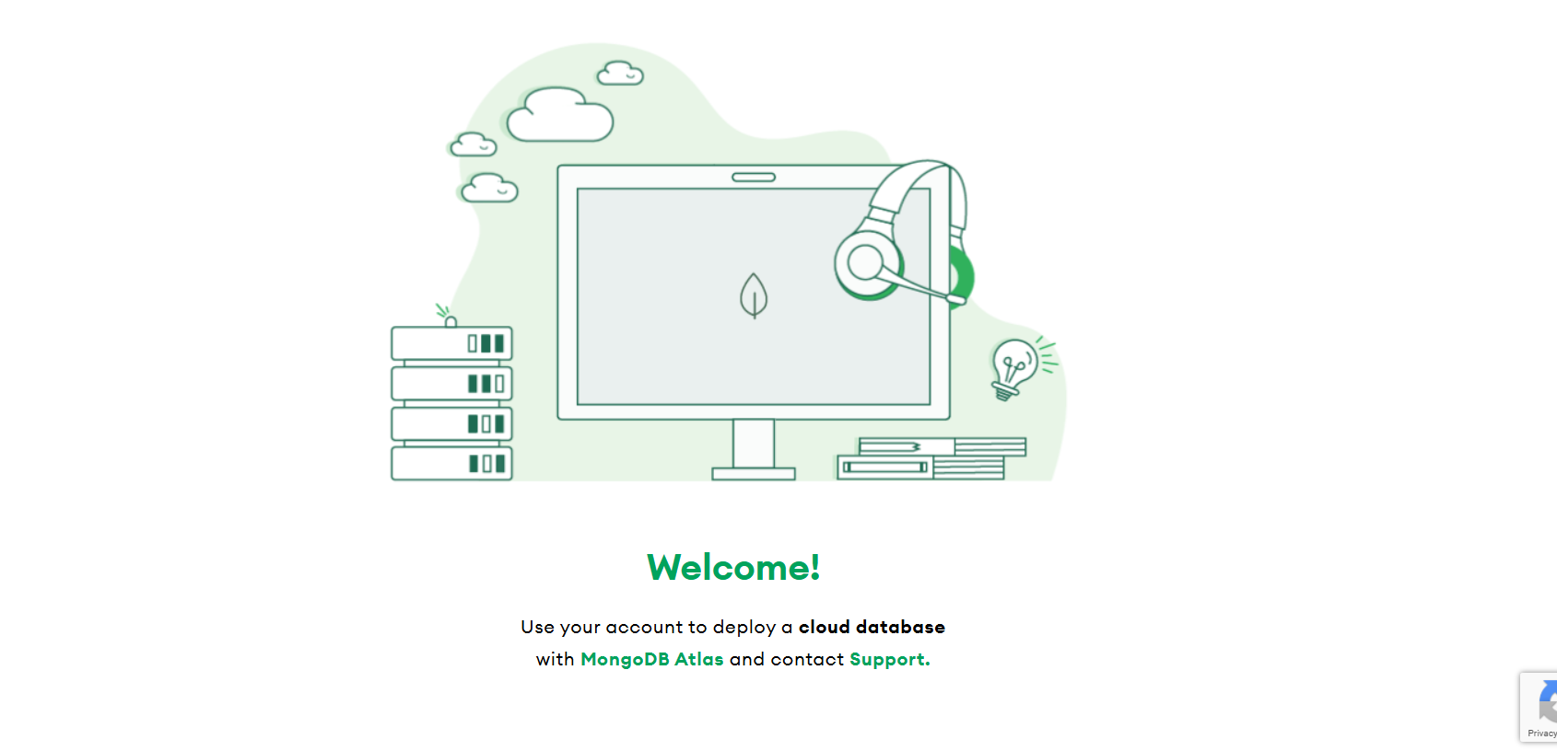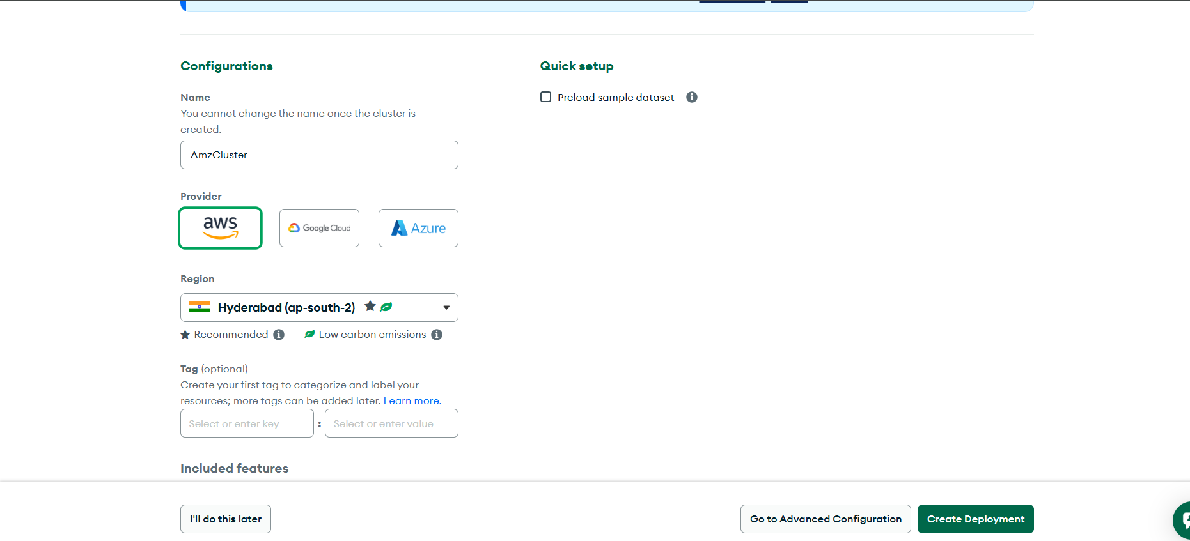

Adding User

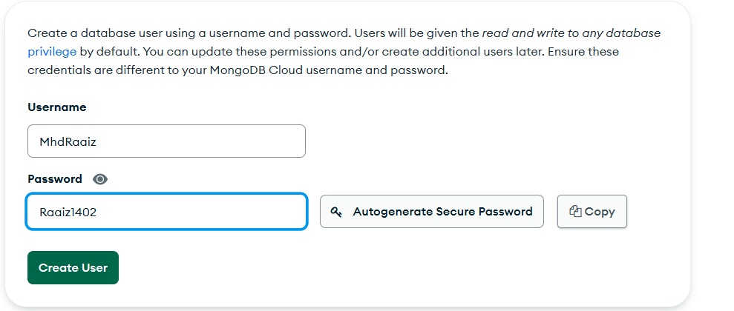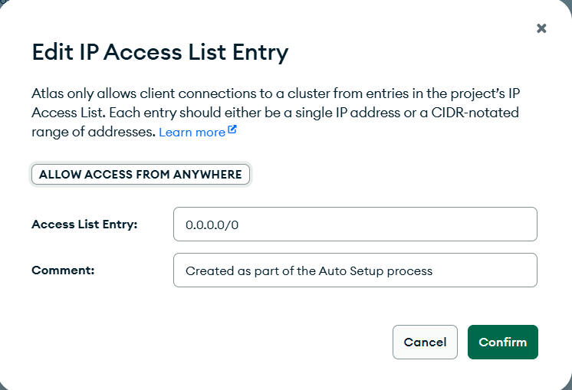

This image shows the MongoDB Atlas interface for editing the **IP Access List**, which controls which IP addresses are allowed to connect to the database cluster. The entry 0.0.0.0/0 is used to **allow access from any IP address**, typically for development or testing purposes. A comment is added for context: “Created as part of the Auto Setup process.” Clicking **Confirm** will apply this rule, enabling open access to the cluster, though it's generally not recommended for production due to security risks.

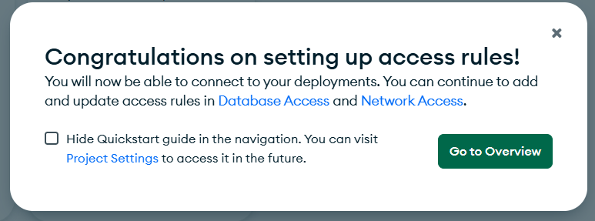

This image shows a confirmation message from MongoDB Atlas indicating that access rules have been successfully set up. It informs the user that they can now connect to their database deployments and manage access settings through the Database Access and Network Access sections. The user has the option to hide the Quickstart guide and proceed to the cluster overview by clicking the "Go to Overview" button. This marks the completion of the access configuration step in setting up a MongoDB environment.



These two images show the configuration steps in **MongoDB Atlas** for enabling secure access and user authentication to a database cluster.

**🔐 First Image – Edit IP Access List Entry**

This window allows users to configure which IP addresses are allowed to access the MongoDB cluster. The IP 0.0.0.0/0 has been entered, which **grants access from any IP address**. This is often used during development but is **not recommended for production** due to security risks. A comment is added for documentation ("Created as part of the Auto Setup process"). Clicking **"Confirm"** applies the rule.

**👤 Second Image – User Authentication Setup**

This part of the UI shows a database user named **MhdRaaiz** with **password-based authentication**. This user account is authorized to connect to the cluster and perform database operations. There are options to **edit or remove** the user.

**✅ Summary:**

These steps collectively configure **network access** (IP whitelisting) and **database user access** (credentials) to ensure MongoDB Atlas can be securely connected from external applications.

**Changing To Cloud Environment**

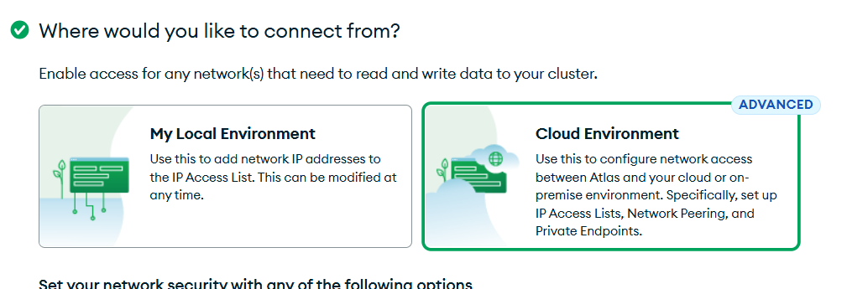

This image is from the **MongoDB Atlas setup interface**, where users are prompted to choose **where they want to connect from** to access their database cluster.

There are two options:

1. **My Local Environment**:  
   This option is for users connecting from their personal computer or local server. It allows them to add their device’s IP address to the **IP Access List** so they can securely read/write data to the cluster. It’s ideal for development or testing.
2. **Cloud Environment** (marked as **Advanced**):  
   This is for users deploying from cloud infrastructure (like AWS, Azure, GCP) or an on-premise server. It allows more complex network configurations such as **Network Peering**, **Private Endpoints**, and broader **IP Access List management**.

**Summary:**

This step lets users configure the network source for secure access to MongoDB Atlas, either from a **local device** or an **advanced cloud/on-premise setup**.

**Implementation on MongoDB Atlas (Data Insertion): (2 Marks)**

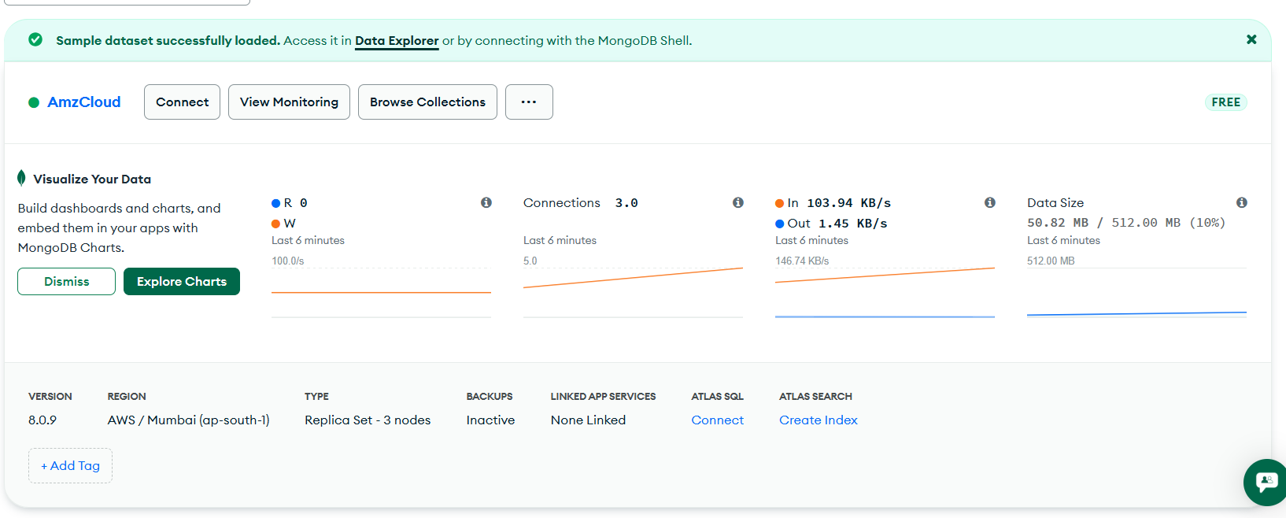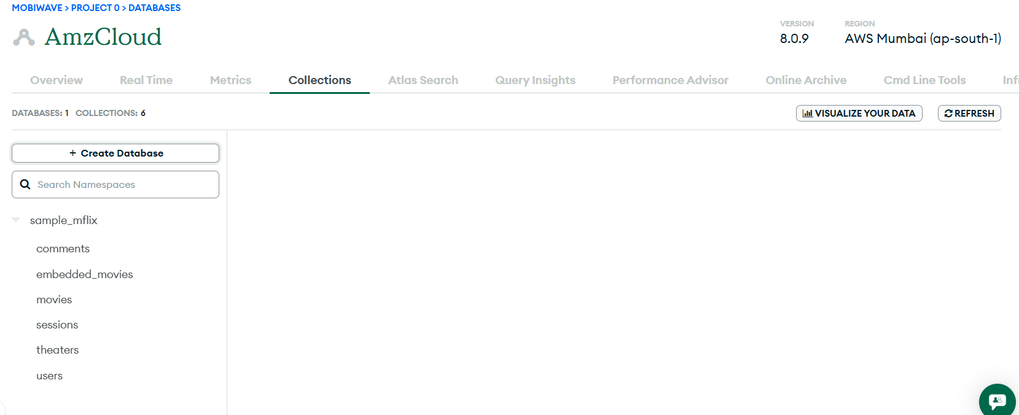

Create Database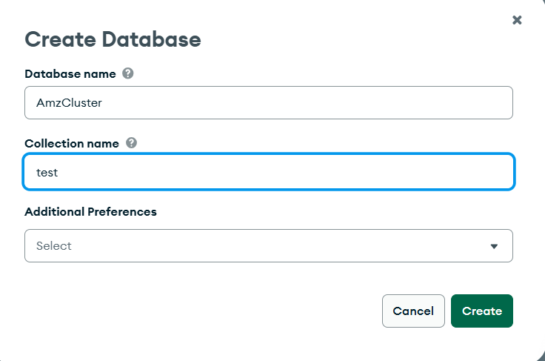

Insert Documentation

Adding Customer Amazon Data Set

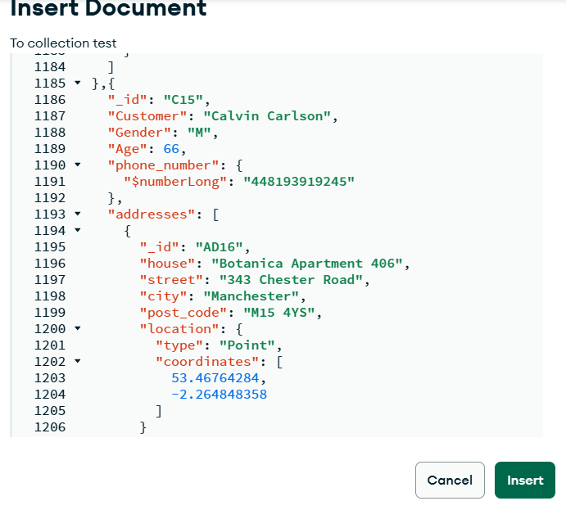 **Document Details:**

* _id: "C15" – Unique identifier for the customer.
* Customer: "Calvin Carlson" – Customer's name.
* Gender: "M" – Male.
* Age: 66 – Age of the customer.
* phone_number: Encoded using $numberLong to ensure large number handling in BSON format.
* addresses: An array containing address objects. In this case, one address is listed with:
  + _id: "AD16"
  + house, street, city, post_code: Full address details
  + location: A **GeoJSON object** with:
    - type: "Point"
    - coordinates: [53.46764284, -2.264848358] – Latitude and longitude for geospatial indexing

**✅ Summary:**

This document defines a customer's full profile with personal, contact, and geolocation-based address data. The structure supports **complex queries** like geospatial searches and is an example of MongoDB's ability to store **richly nested documents**.

**Query Results**

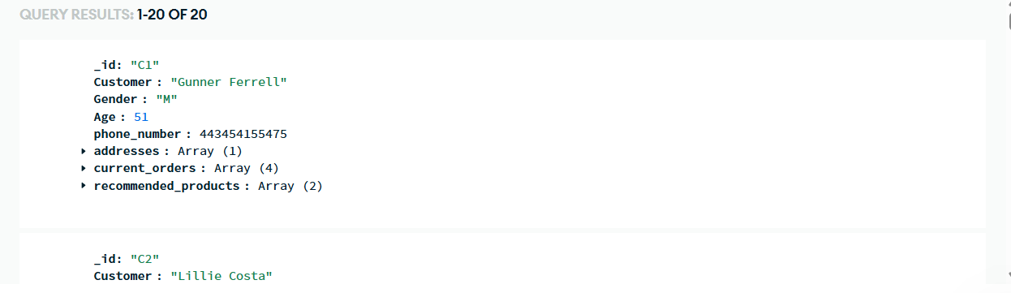

**Document Breakdown:**

* **Customer 1**:
  + _id: "C1"
  + Customer: "Gunner Ferrell"
  + Gender: "M"
  + Age: 51
  + phone_number: 443454155475
  + addresses: Contains an **array** of address documents (collapsed view shows 1 address).
  + current_orders: An array with **4 active orders**.
  + recommended_products: An array suggesting **2 products** for this customer.
* **Customer 2**:
  + _id: "C2"
  + Customer: "Lillie Costa"  
    *(rest of the details are not visible in the image)*

**✅ Summary:**

The image shows structured MongoDB documents retrieved from a customers collection. Each document stores **customer demographics, contact info, addresses, active orders, and product recommendations** using nested arrays. This demonstrates MongoDB's flexibility in handling complex, real-world data structures.

Creating Python Files & Importing Data

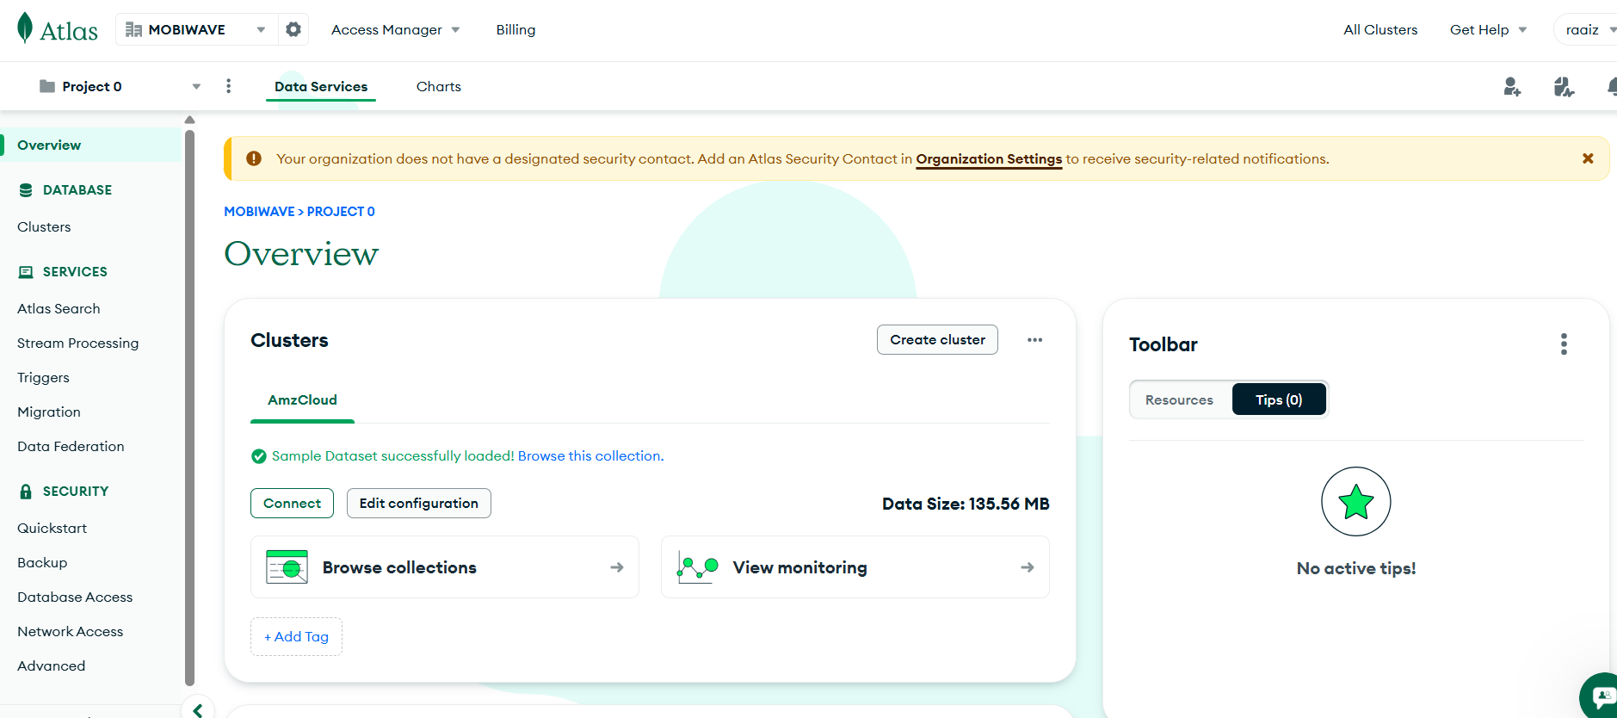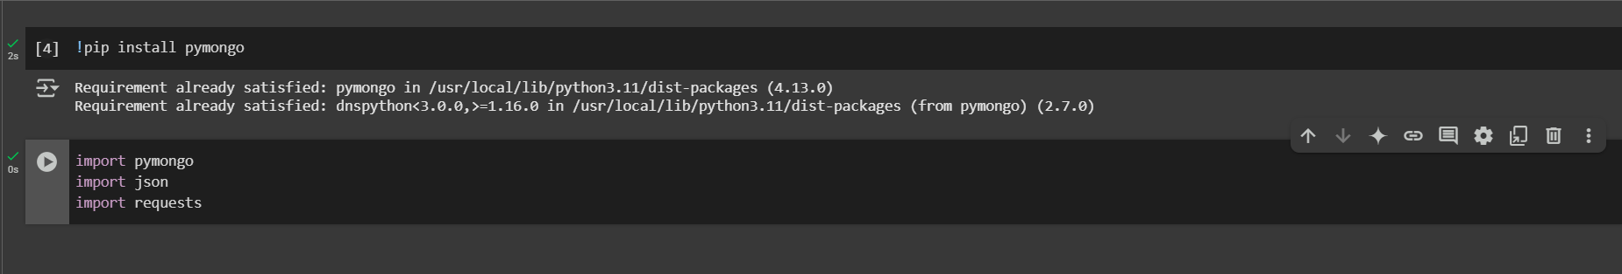

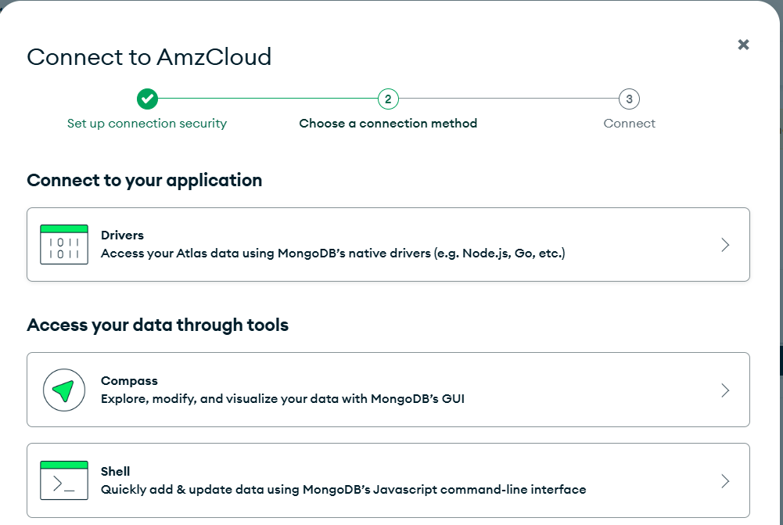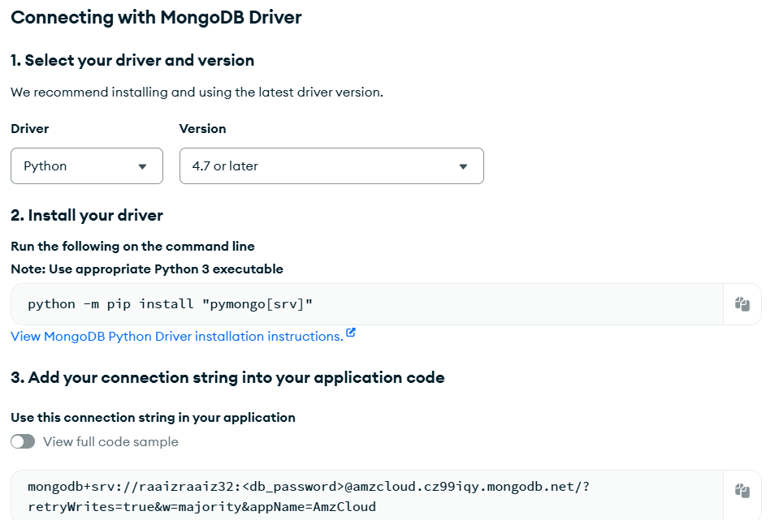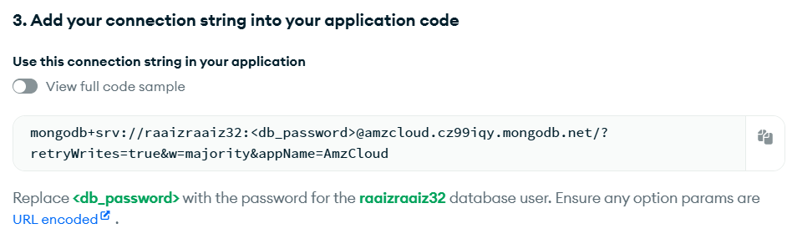

These images provide a step-by-step guide to connect a Python application to a MongoDB Atlas database. First, the Python driver (pymongo[srv]) is installed using the command python -m pip install "pymongo[srv]". Then, a connection string is provided, which includes the database username (raaizraaiz32) and a placeholder for the password (<db_password>). This connection string should be inserted into the Python application code to establish a secure link to the MongoDB cluster. Users are reminded to replace the placeholder with the actual password and ensure any URL parameters are properly encoded. This setup enables secure remote access to MongoDB from Python.

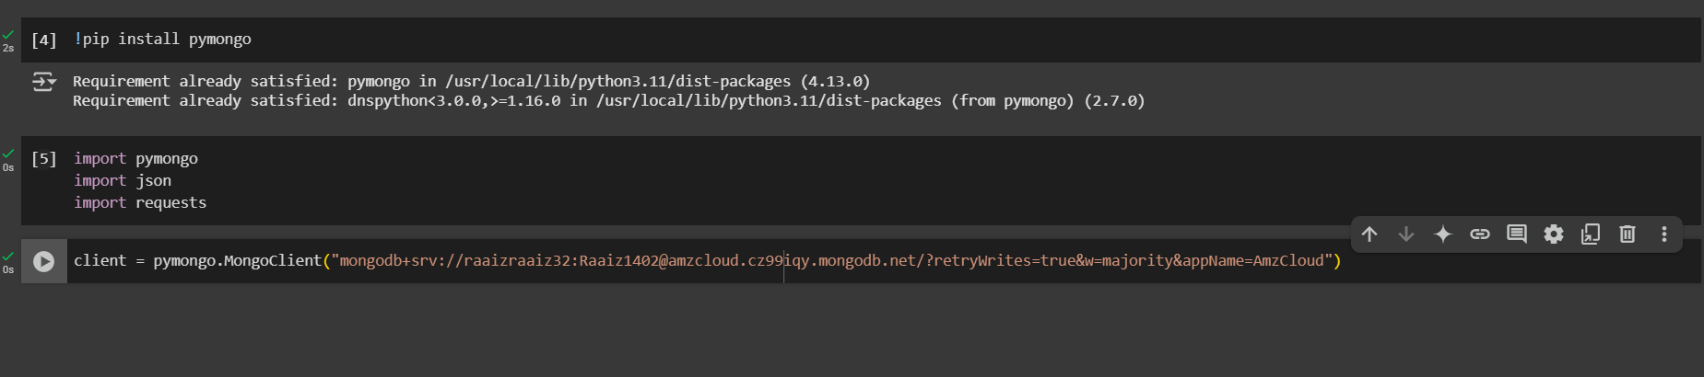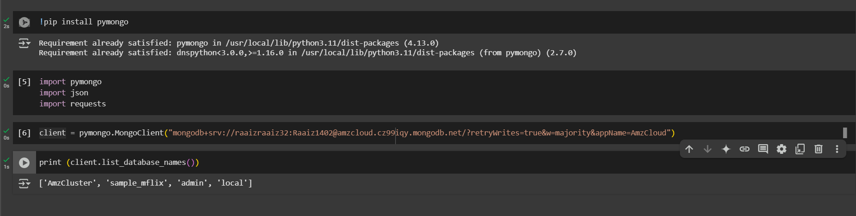

This image shows a Jupyter Notebook where a MongoDB connection is being established using the pymongo library. The code first installs pymongo (though it is already satisfied), then imports necessary libraries like pymongo, json, and requests. A MongoDB client is created using the MongoClient() method with a connection string that includes the user's credentials and cluster information. Finally, the code prints the list of available databases on the MongoDB cluster using client.list_database_names(), and the output confirms a successful connection by listing databases such as 'AmzCluster', 'sample_mflix', 'admin', and 'local'.

**Designing NoSQL Schema for Company & Data Manipulation in MongoDB: (10 Marks)**



Results of inserted data

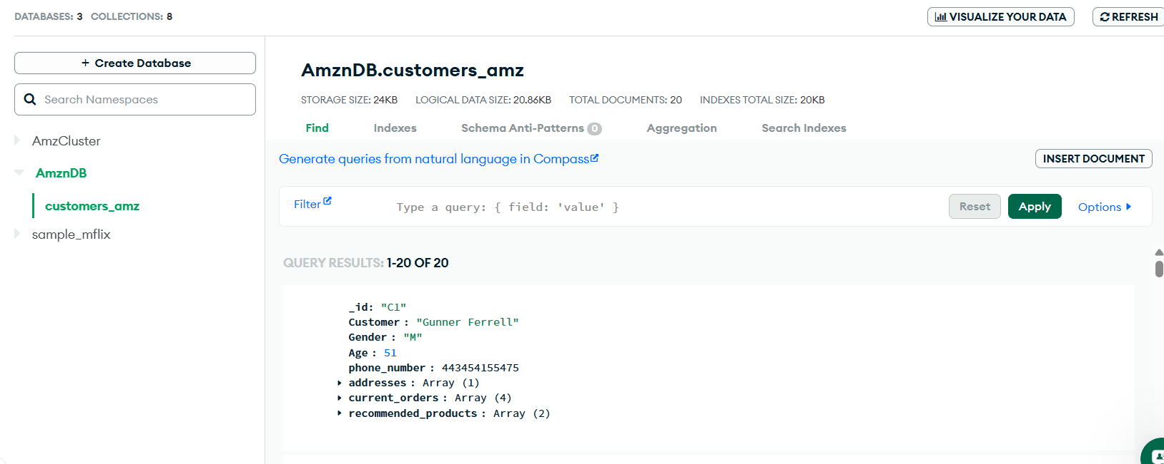

This image shows the **MongoDB Atlas web interface** displaying the contents of the **customers_amz collection** within the **AmznDB database**. The interface indicates that there are **20 documents** stored in this collection, using **24KB of storage** and **20KB for indexes**. A specific document is shown as part of the query results, representing a customer named **Gunner Ferrell** with fields such as _id, Gender, Age, phone_number, and arrays for addresses, current_orders, and recommended_products. The interface provides tools to filter, insert, and analyze documents, making it easy to manage and query the database visually.

**Designing NoSQL Schema for Company: (5 Marks)**

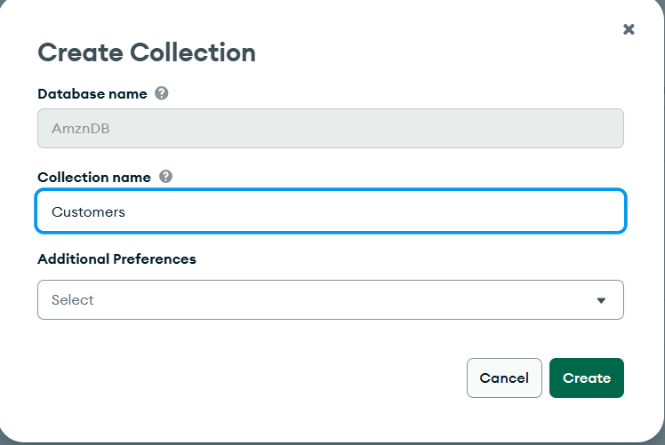

**NOSQL**

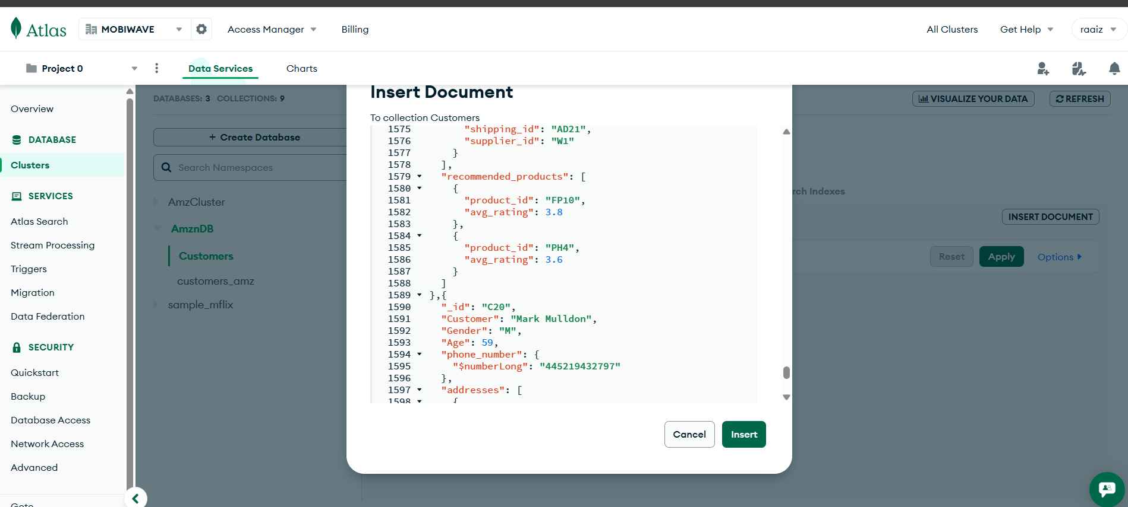

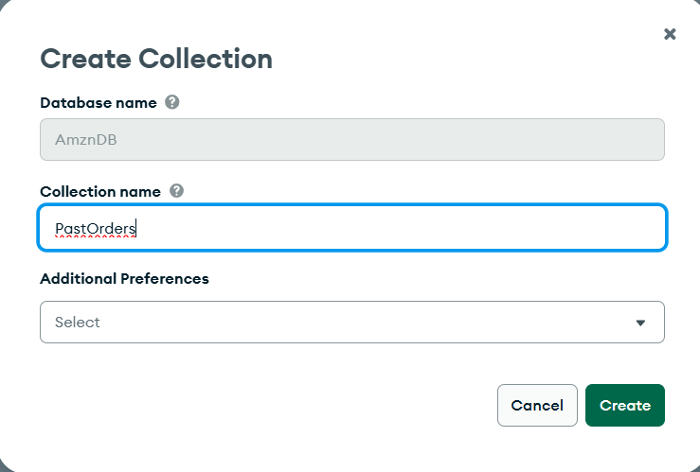

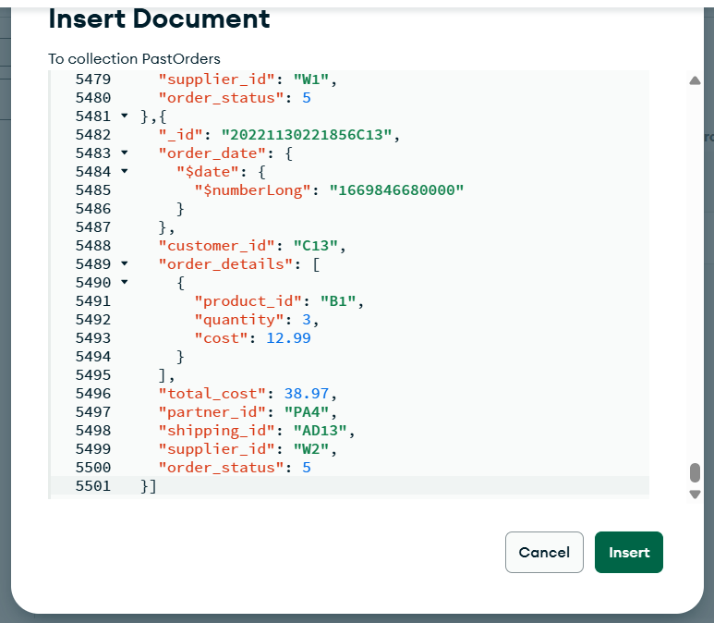

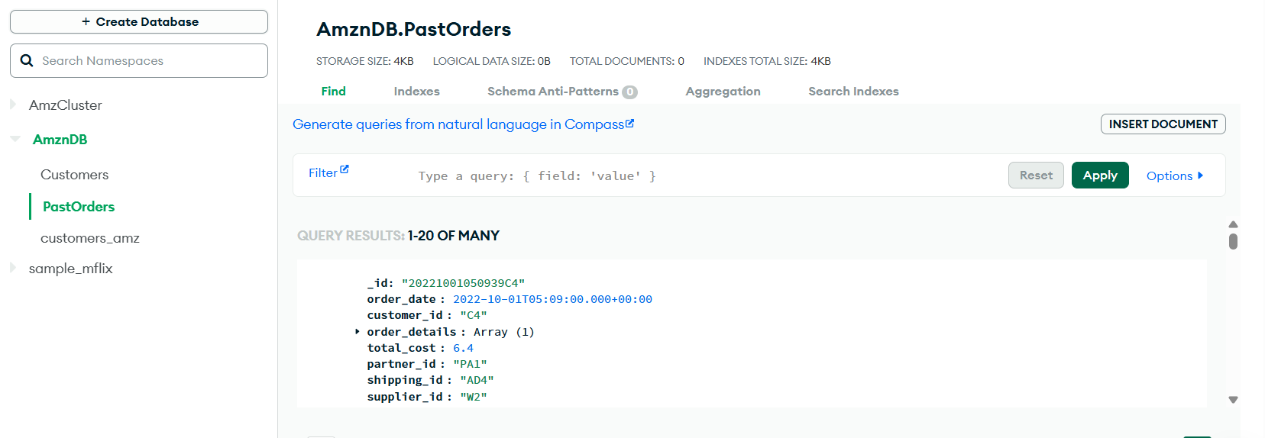

Inserting Partner DataSet

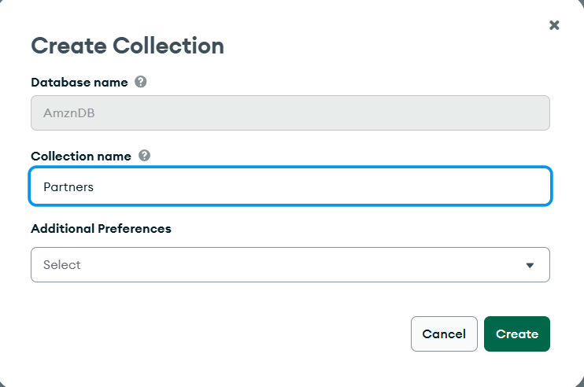

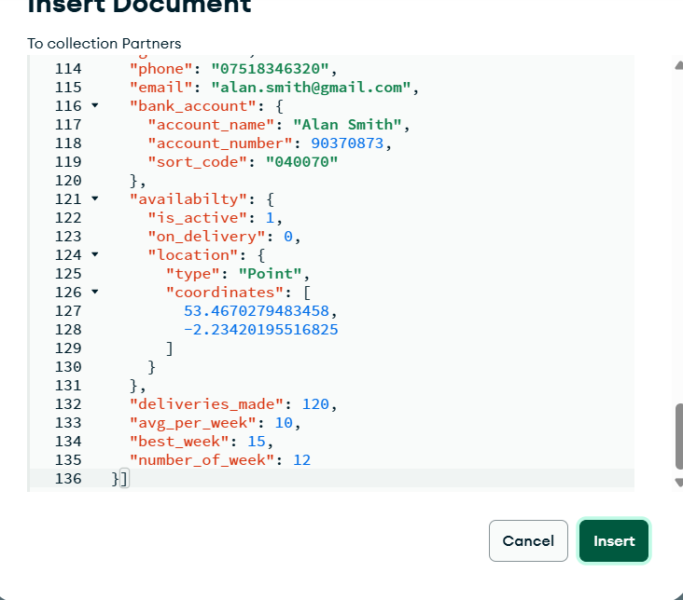

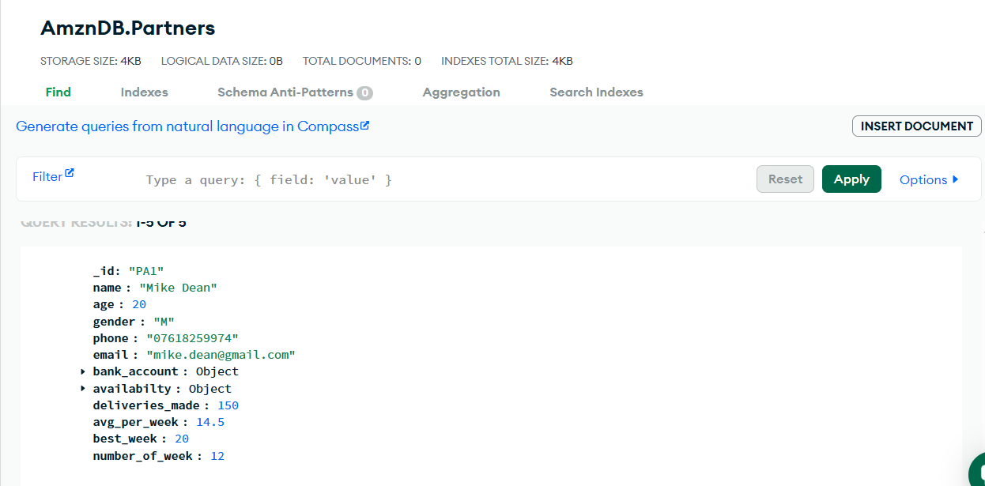

This image displays a document from the **Partners collection** in the **AmznDB database** within the MongoDB Atlas interface. The document shown represents a delivery partner named **Mike Dean** with the ID "PA1".

**Summary:**

This document showcases structured partner information including personal details, contact info, banking, and delivery performance metrics. The use of embedded objects like availability and bank_account highlights MongoDB’s flexibility in handling nested data. The interface allows viewing, filtering, and managing documents effectively within the collection.

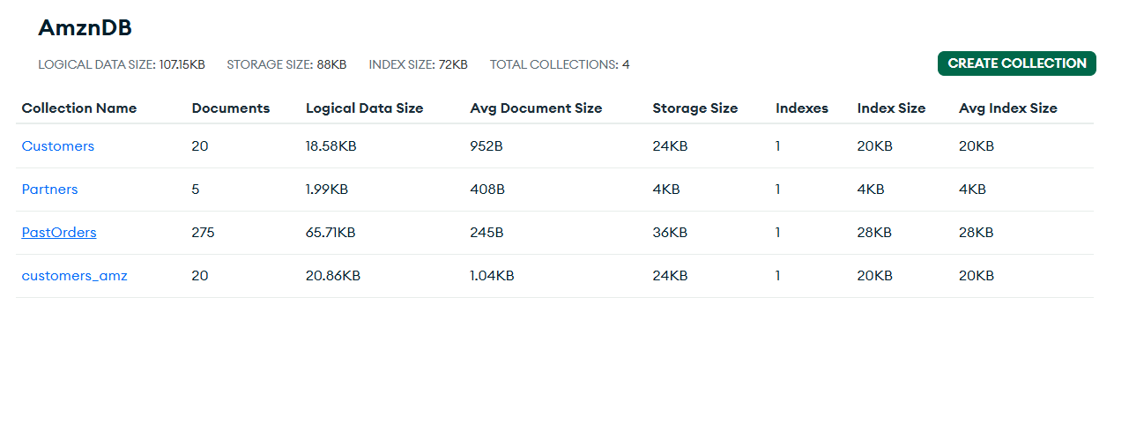

Including Ratings

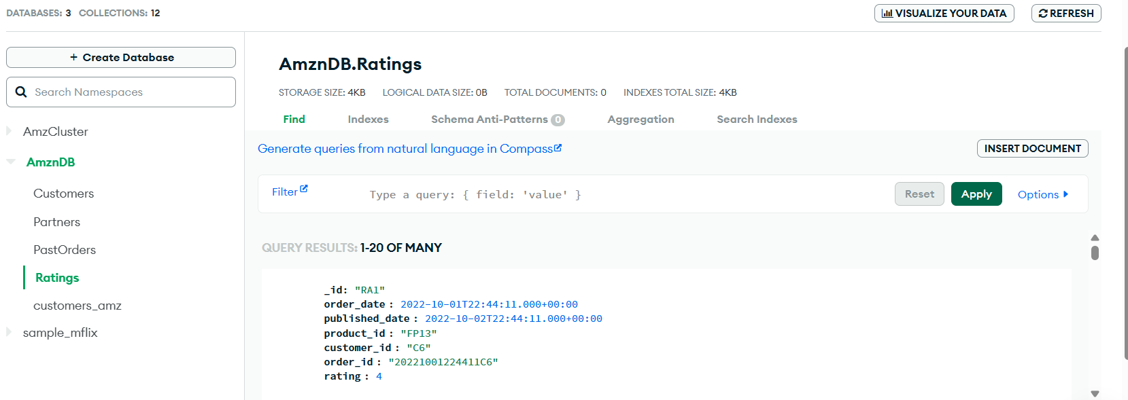

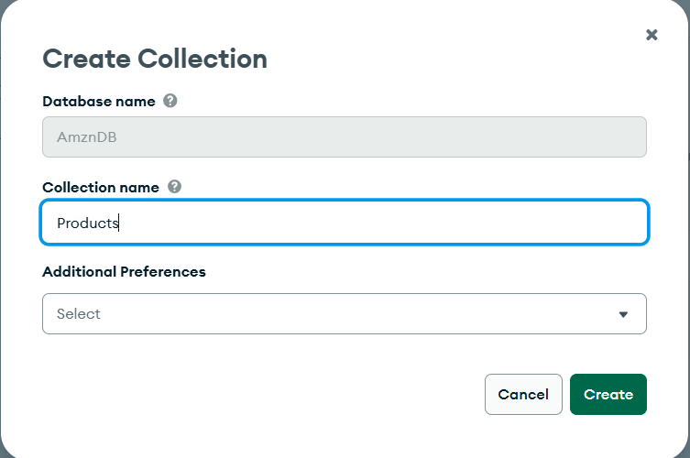

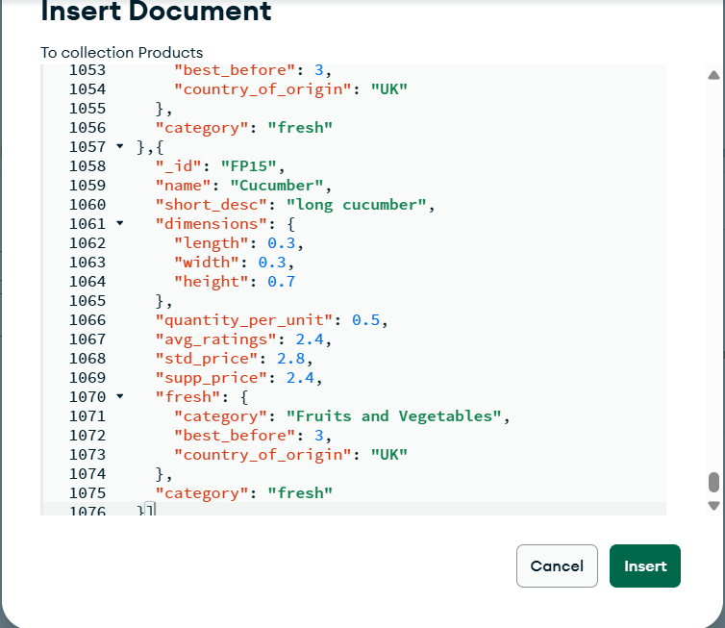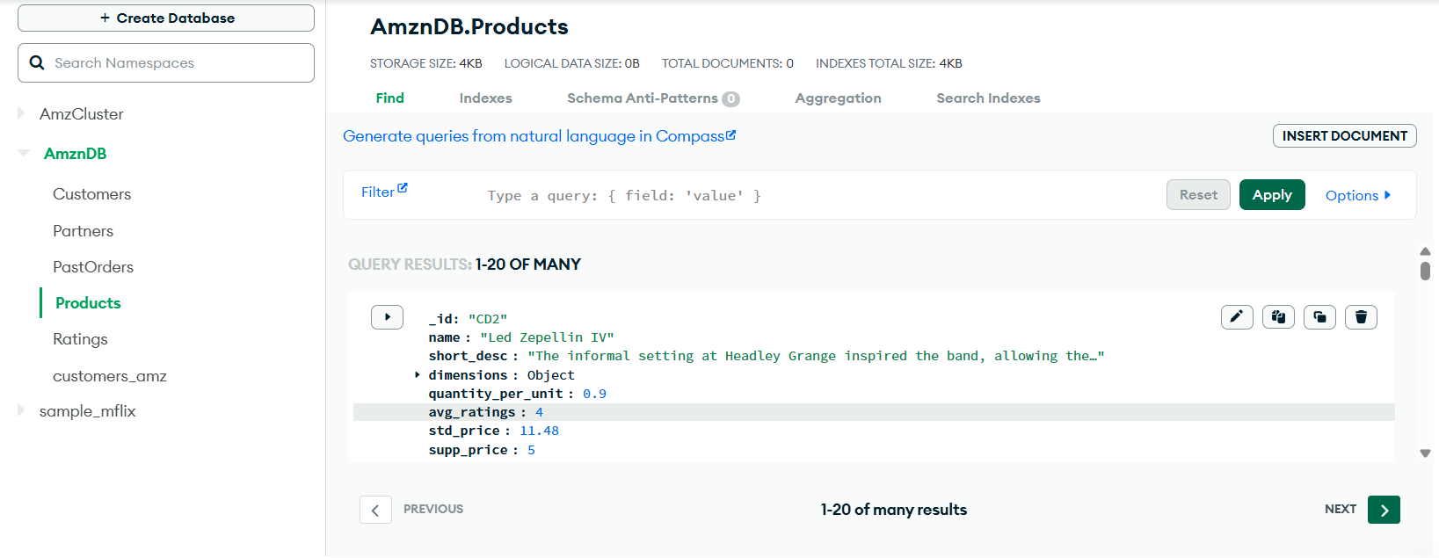

This image shows the **MongoDB Atlas interface** displaying the contents of the **Products collection** inside the **AmznDB database**. It shows that the collection currently has **no logical data size**, with a **storage size of 4KB** and **index size of 4KB**, indicating lightweight data usage.

A product document is partially visible in the query results, showing:

* _id: "CD2"
* name: "Led Zeppelin IV"
* short_desc: A truncated description of the product
* quantity_per_unit: 0.9
* avg_ratings: 4
* std_price: 11.48
* supp_price: 5

The UI allows users to **filter, edit, duplicate, delete, or expand** documents. This view enables efficient browsing and management of product data within the Products collection.

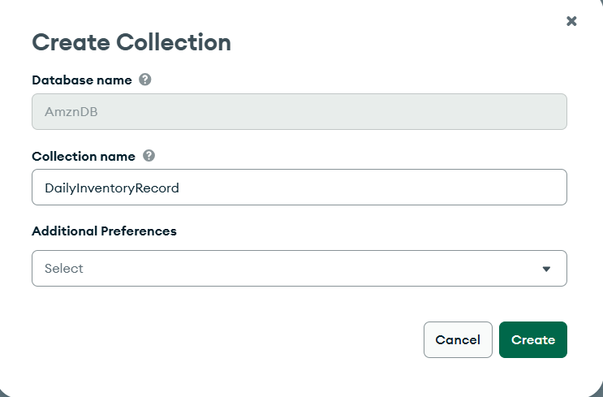

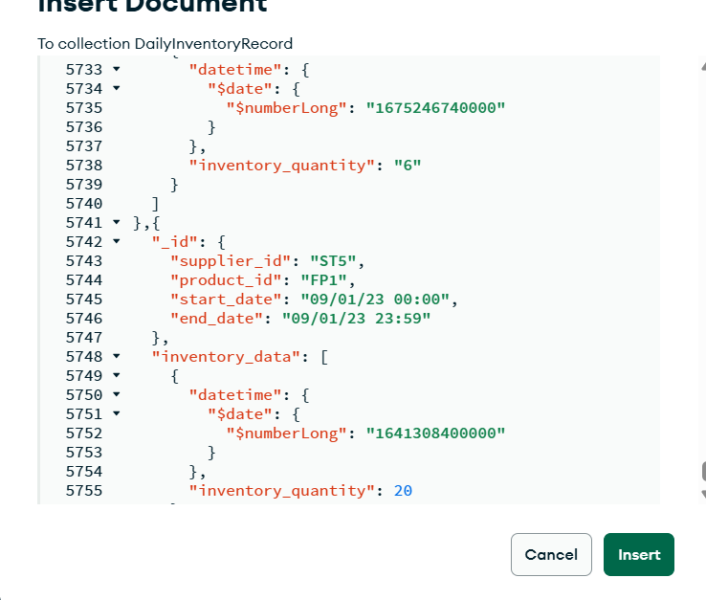

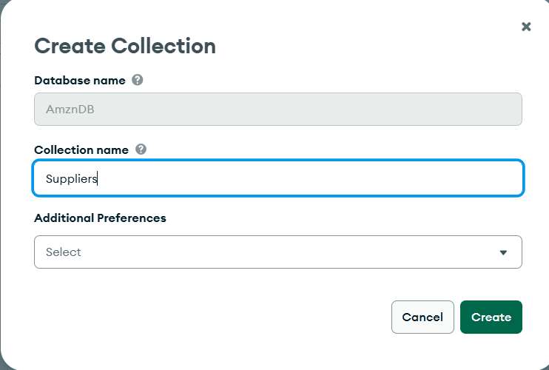

This image shows the **MongoDB Atlas interface** for creating a new **collection** within a database.

* The **Database name** is pre-filled as **AmznDB**, meaning the new collection will be part of this existing database.
* The user is entering **Suppliers** as the **Collection name**, indicating that this collection will store supplier-related data such as supplier IDs, names, contact details, locations, etc.
* The **Additional Preferences** section provides optional settings like setting a schema validator or defining storage options, though no preferences have been selected here.
* Two buttons at the bottom—**"Cancel"** and **"Create"**—allow the user to either discard or confirm the creation of the new collection.

**✅ Summary:**

This step finalizes the process of adding a new Suppliers collection to the AmznDB database, enabling the storage and management of supplier data within MongoDB Atlas.

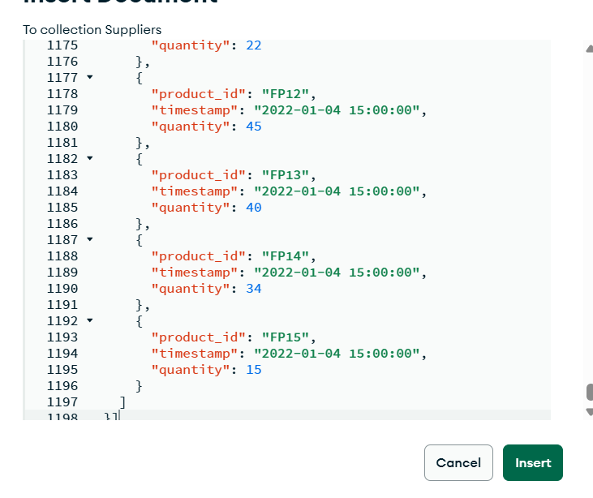

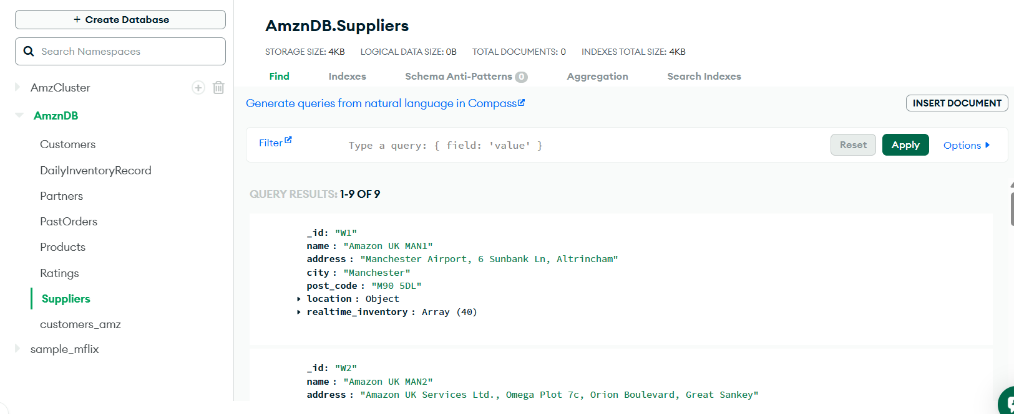

Entered Data Collection

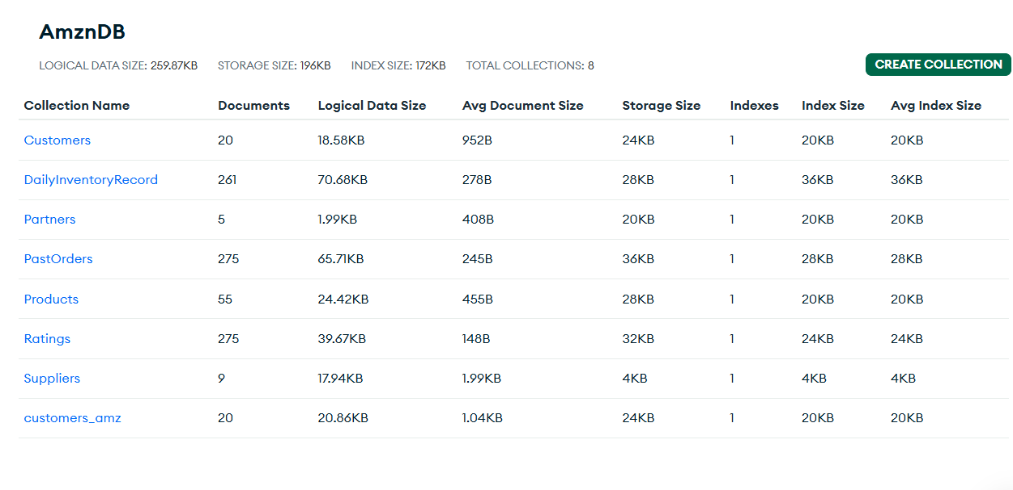

**NOSQL**

Creating Partner History

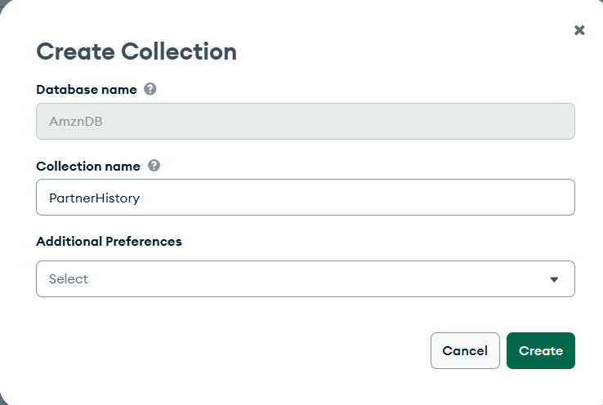

This image shows the **MongoDB Atlas interface** for creating a new collection within a database.

* The **Database name** is preset to **"AmznDB"**, meaning the new collection will belong to this existing database.
* The user has entered **"PartnerHistory"** in the **Collection name** field, indicating that this collection will store historical data related to delivery or business partners (e.g., shifts, orders, or activity logs).
* The **Additional Preferences** dropdown allows users to set optional configurations such as schema validation, indexing options, or storage engine preferences (though no selection is made here).
* Two buttons are provided: **Cancel** (to discard the operation) and **Create** (to confirm and add the collection to the database).

This step is part of structuring a NoSQL database by organizing related documents into logical groups called collections.

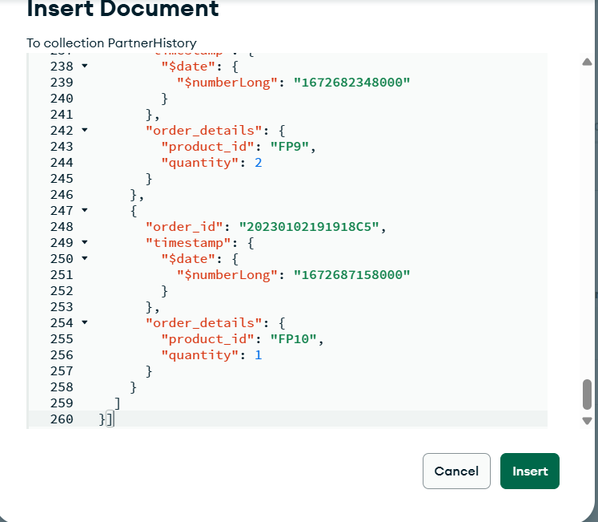

This image shows a document being inserted into the **PartnerHistory collection** in MongoDB using the Atlas UI. The document contains an array of **order records**, where each record includes:

* order_id: A unique identifier for the order (e.g., "20230102191818C5").
* timestamp: The time the order was placed, represented in Unix epoch format using the $date and $numberLong notation (used for precise time storage in BSON).
* order_details: An embedded object that holds the product_id (e.g., "FP9" or "FP10") and the corresponding quantity (2 or 1).

This structure allows MongoDB to efficiently store and track historical order activity linked to a delivery partner, with detailed information on when the orders were made and what products were involved. It supports nested data and time-based queries, which are useful for analytics and reporting.

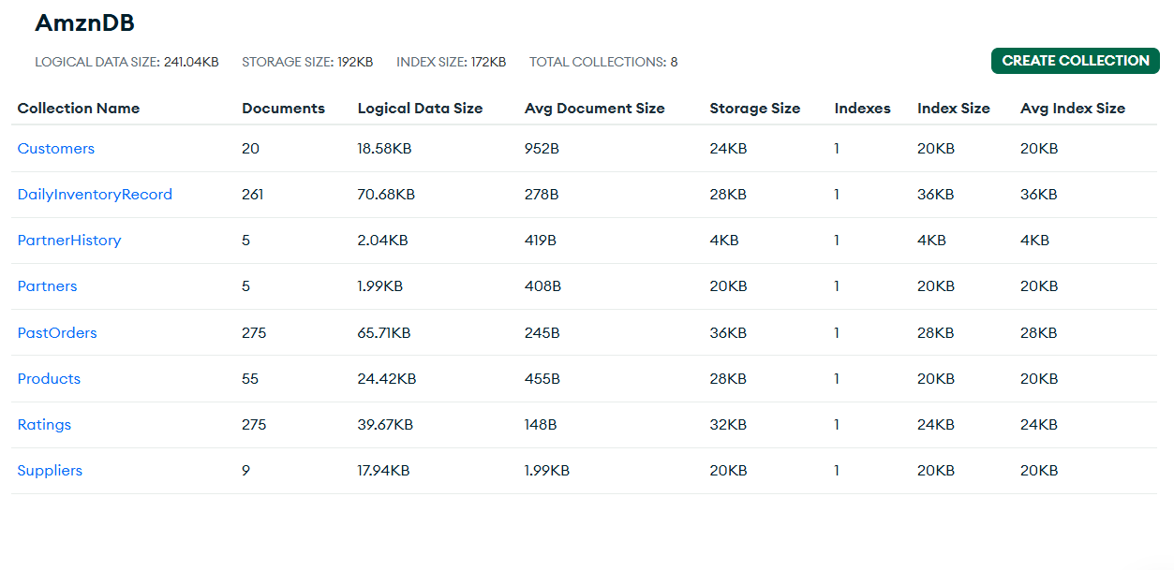

This image displays an overview of the **AmznDB MongoDB database**, showing detailed statistics for each of its 8 collections. These include Customers, DailyInventoryRecord, PartnerHistory, Partners, PastOrders, Products, Ratings, and Suppliers. For each collection, key metrics are listed such as the number of documents, logical data size, average document size, storage size, number of indexes, and index sizes. Notably, PastOrders and Ratings have the highest document count (275), indicating heavy usage, while collections like Partners and PartnerHistory have only 5 documents each. This summary provides a clear snapshot of how data is distributed and indexed within the database, helping in performance monitoring and optimization.

**Data Manipulation**

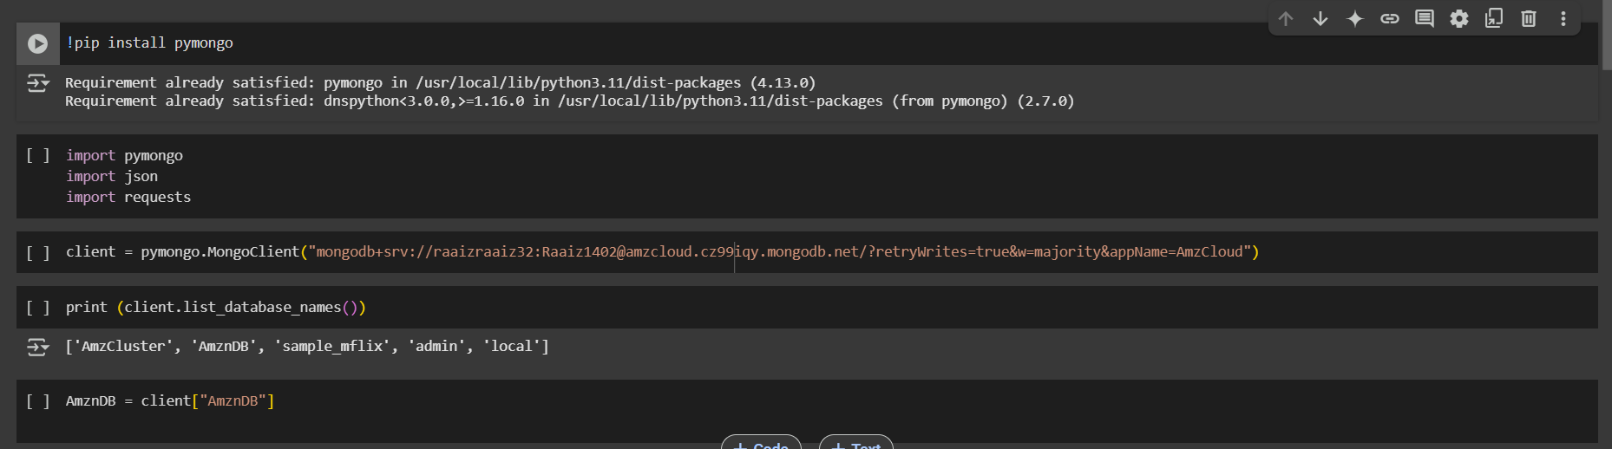

1. **Installation**:  
   The command !pip install pymongo installs the pymongo library, but it is already installed as indicated by the message.
2. **Importing Libraries**:  
   The code imports three Python libraries: pymongo for MongoDB operations, json for handling JSON data, and requests for making HTTP requests (though not used here yet).
3. **MongoDB Connection**:  
   A MongoDB client is created using the MongoClient() constructor with a connection string that connects to a cloud-hosted MongoDB database (MongoDB Atlas).
4. **Database Listing**:  
   client.list_database_names() is used to print the list of all databases available on the connected MongoDB cluster. The output includes databases like 'AmzCluster', 'AmznDB', 'sample_mflix', 'admin', and 'local'.
5. **Database Selection**:  
   The last line assigns the database named "AmznDB" to the variable AmznDB, preparing it for further operations like querying or inserting data.

This setup confirms a successful connection and prepares the environment for performing data operations in MongoDB.

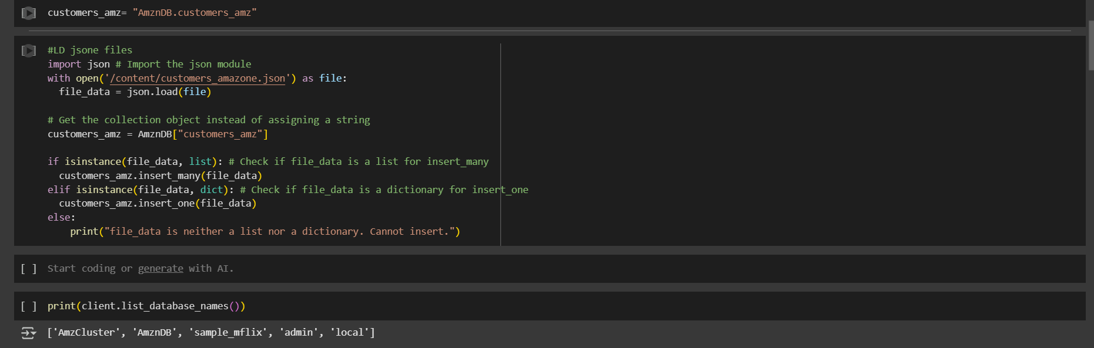

This Python code is used to insert JSON data into a MongoDB collection. It starts by opening a JSON file named customers_amazon.json and loading its contents into a variable called file_data. It then connects to the customers_amz collection in the AmznDB database. The script checks whether the data is a list or a single dictionary. If it's a list (indicating multiple documents), it inserts them using insert_many(). If it's a single dictionary (one document), it uses insert_one(). If the data is neither, it prints an error message. Finally, it lists all the databases available on the MongoDB client to confirm that the connection is active and working correctly.

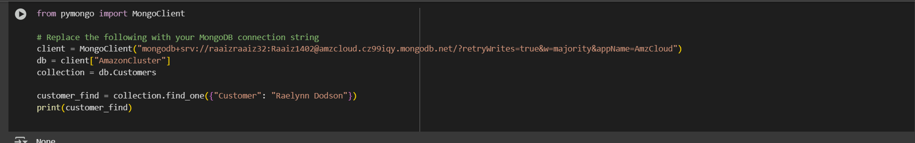

This Python script connects to a MongoDB Atlas database named **"AmazonCluster"** using the pymongo library and accesses the **"customers"** collection. It attempts to find a document where the "customer" field is equal to "Raelynn Dodson" using the find_one() method. The result is then printed. Since the output is None, it indicates that no customer with that name exists in the database. This is a typical MongoDB query operation used to retrieve a specific record based on a field value.

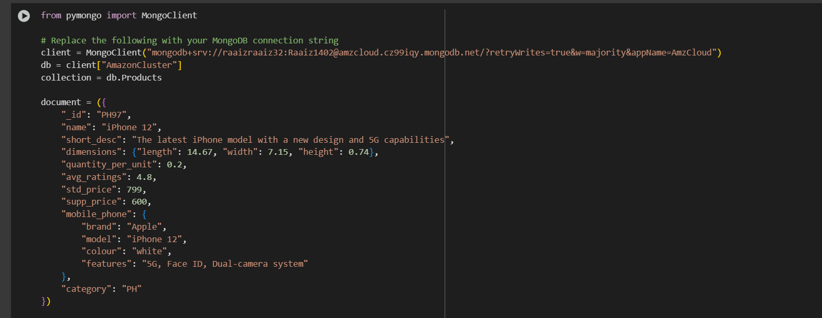

**Summary Explanation of the Code**

This script demonstrates how to **create and prepare a MongoDB document** using pymongo for insertion into the Products collection within the AmazonCluster database.

**Document Content:**

* _id: "PH97" – Unique identifier.
* name: "iPhone 12" – Product name.
* short_desc: Brief description highlighting the 5G and design features.
* dimensions: Length, width, and height of the phone.
* quantity_per_unit: 0.2 (possibly in kg or liters).
* avg_ratings: 4.8 – average customer rating.
* std_price: 799 – retail price.
* supp_price: 600 – supplier price.
* mobile_phone: Nested details including brand, model, color, and features.
* category: "PH" – product category code.

**Use Case:**

This JSON-like object defines the structure of a **product record (iPhone 12)** before inserting it into MongoDB. It ensures the document is **well-structured and nested**, suitable for use in **NoSQL data modeling**.

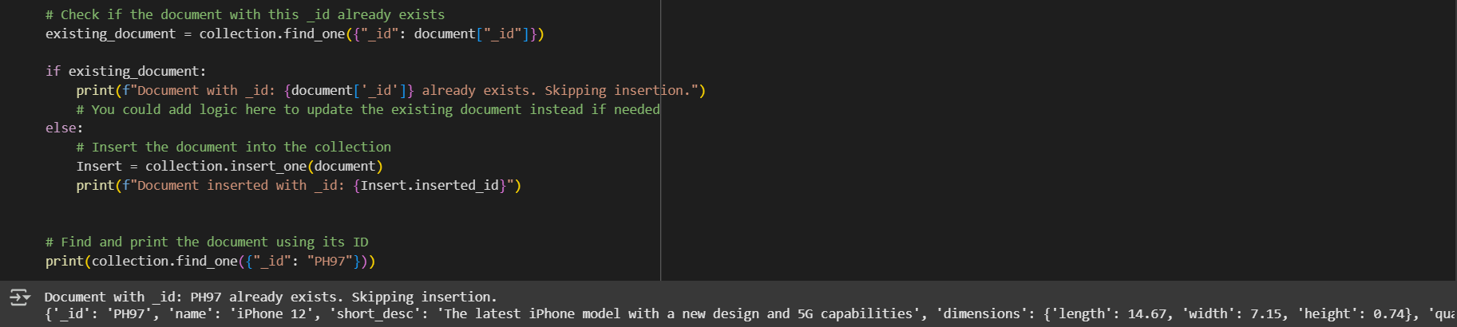

This Python script performs a **conditional insert** operation in MongoDB using pymongo. It checks if a document with the given _id ("PH97") already exists in the **Products** collection. If it does, it prints a message saying the insertion is skipped. Otherwise, it inserts the document and confirms with the inserted _id. In this case, the log confirms:

"Document with _id: PH97 already exists. Skipping insertion."

It then prints the existing document, which contains detailed product info (e.g., **iPhone 12**, dimensions, and short description).

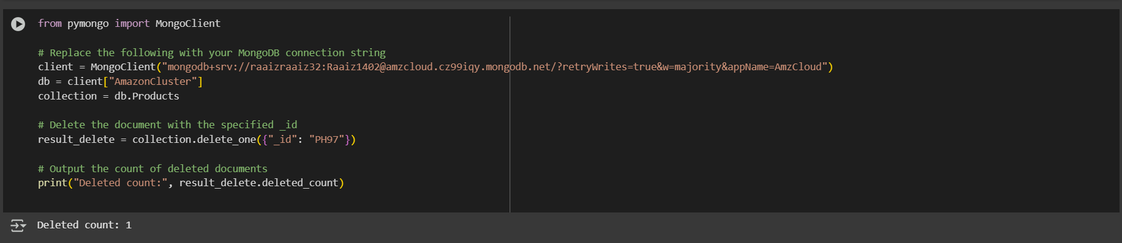

This Python script demonstrates how to **delete a specific document** from a MongoDB collection using pymongo. The script connects to a MongoDB Atlas database named **"AmazonCluster"**, selects the **"Products"** collection, and then uses delete_one() to remove the document with the _id of "PH97". It finishes by printing the number of documents deleted, which confirms successful deletion with the output:  
**"Deleted count: 1"**.

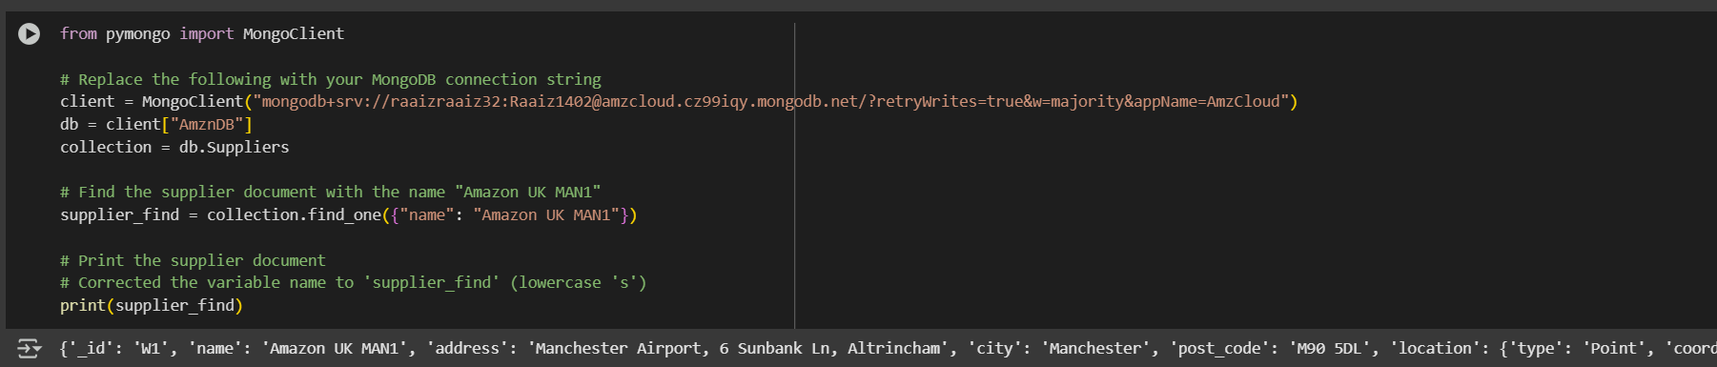

This Python script connects to a MongoDB Atlas database named **"AmznDB"** using pymongo. It accesses the Suppliers collection and searches for a specific supplier document with the name **"Amazon UK MAN1"** using find_one(). Once located, the matching supplier document is printed. The retrieved record includes details such as _id, name, address, city, postcode, and geolocation (with latitude and longitude) of the supplier's warehouse located in Manchester, UK.

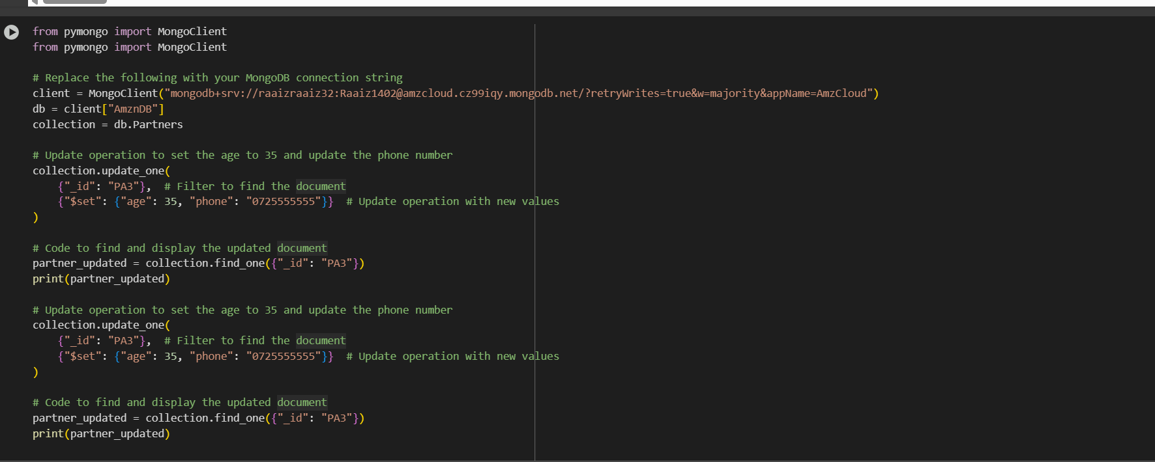

**Operation Performed:**

1. **Connects to the MongoDB Atlas database** AmznDB and accesses the Partners collection.
2. **Updates a partner record** (_id: "PA3") by:
   * Setting the age to 35
   * Updating the phone number to "0725555555"
3. **Verifies the update** using find_one() and prints the updated document.

**Summary:**

This code connects to MongoDB, modifies specific fields in a document (age, phone) using update_one(), and confirms the changes by retrieving and printing the updated record.



**Creating Plots for Numerical Features: (3 Marks)**

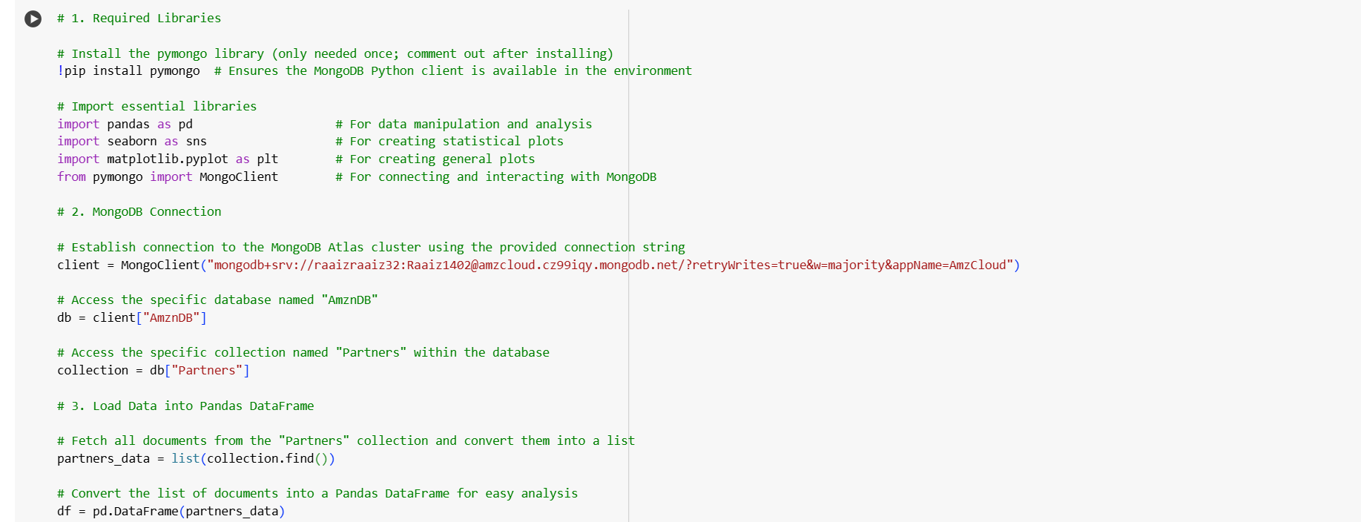

This code connects to a **MongoDB Atlas database** and loads data into a **Pandas DataFrame** for analysis. It starts by importing essential libraries (pandas, seaborn, matplotlib, and pymongo), then connects to the MongoDB cluster using a connection string. The script accesses the database named **"AmznDB"**, selects the **"Partners"** collection, fetches all documents using find(), and converts them into a list. Finally, it loads this list into a Pandas DataFrame named df, making it ready for further data analysis and visualization.

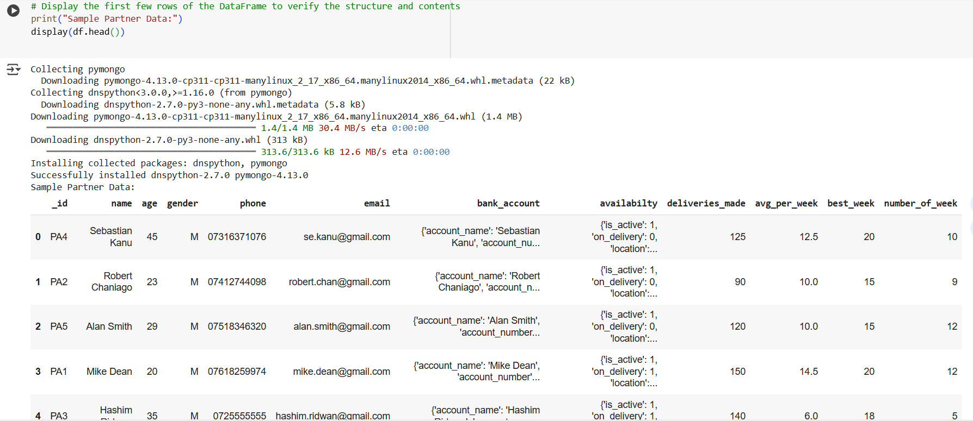

The screenshot displays the first five rows of a delivery partner dataset using df.head() in Python. Each row represents a partner and includes fields such as ID, name, age, gender, contact details, bank account, and performance metrics like deliveries_made, avg_per_week, best_week, and number_of_week. The data also contains a nested availability field indicating whether the partner is currently active or on delivery. This preview confirms that the dataset is well-structured for further analysis.

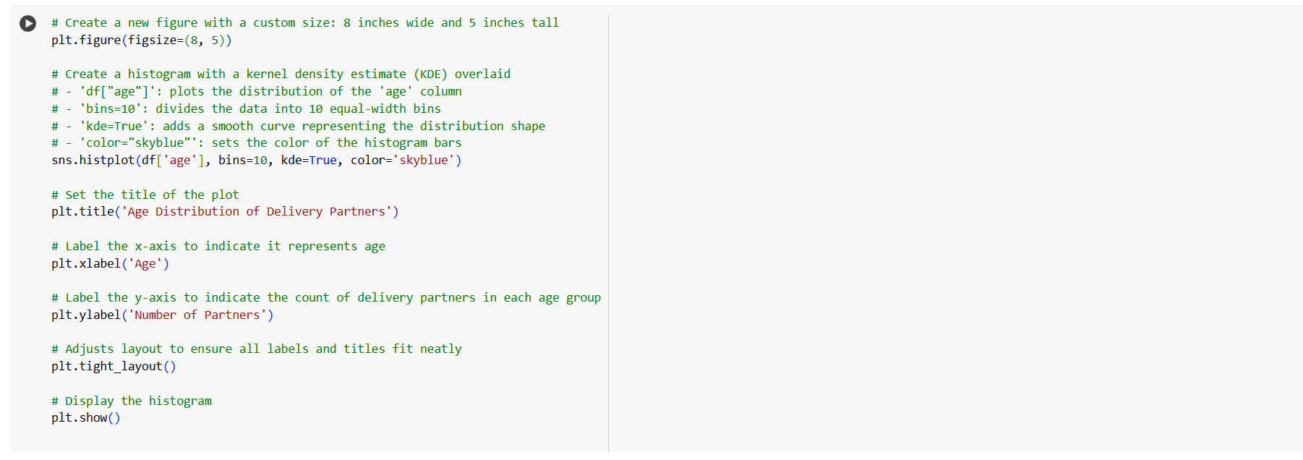

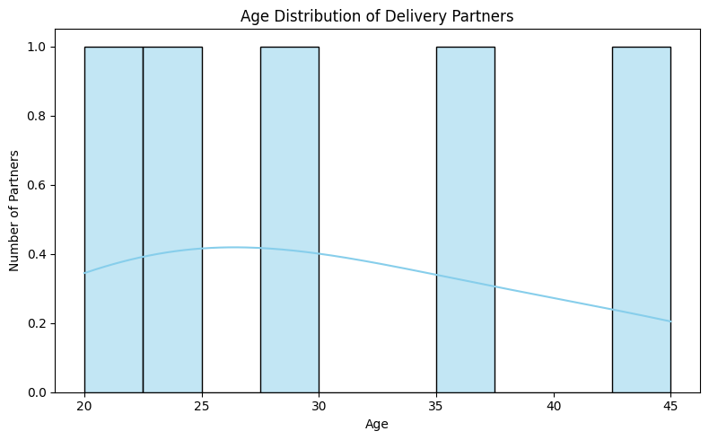

**📊 Chart Title: Age Distribution of Delivery Partners**

**✅ Summary Explanation:**

This is a **histogram** showing how many delivery partners fall within each **age group**. Here's a breakdown:

* The **X-axis** represents the **Age** of the delivery partners.
* The **Y-axis** shows the **Number of Partners** in each age bin.
* The **blue bars** represent counts (all equal to 1), indicating that **each age group has only 1 partner**.
* A **blue density curve** is overlaid to show the trend or pattern in age distribution.

**🔍 Insights:**

* Delivery partners are **evenly spread** across ages: 20, 25, 30, 35, 40, and 45.
* There's a slight **peak around age 25–30**, shown by the mild rise in the density curve.
* The curve gently **declines after age 30**, suggesting slightly fewer older partners.

**📌 Final Summary:**

The histogram shows a uniform distribution of delivery partners across all age brackets, with a subtle concentration in the mid-20s to early 30s range. Each age group from 20 to 45 is represented, indicating a **diverse age workforce** with **no strong skew toward any particular age**.

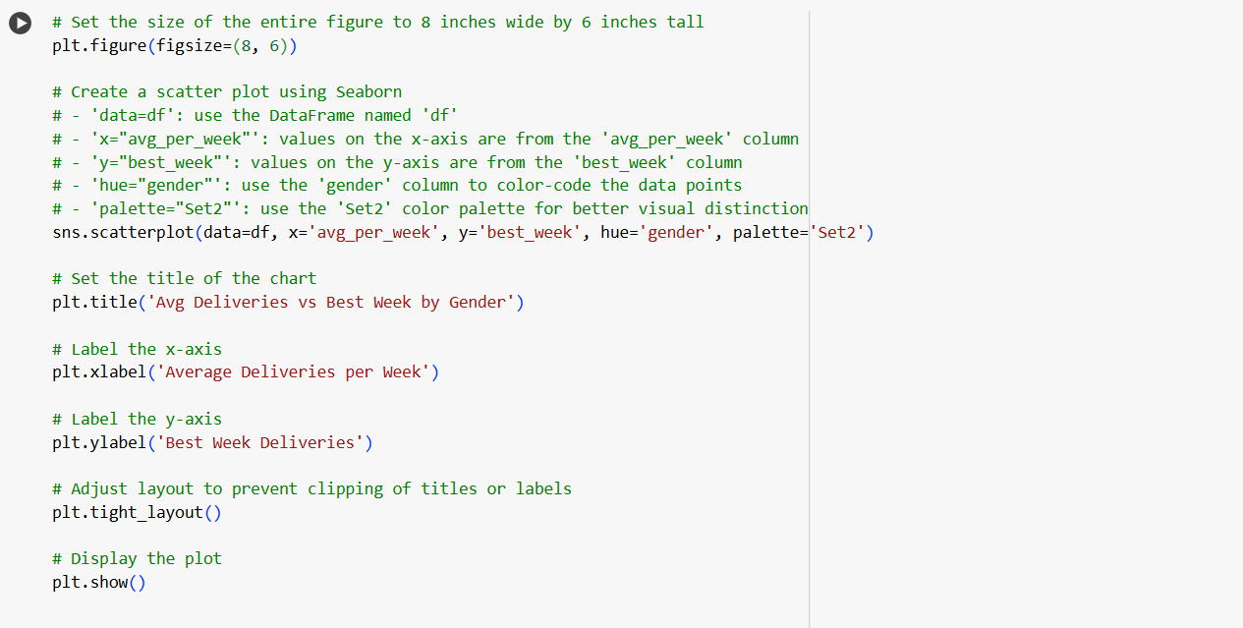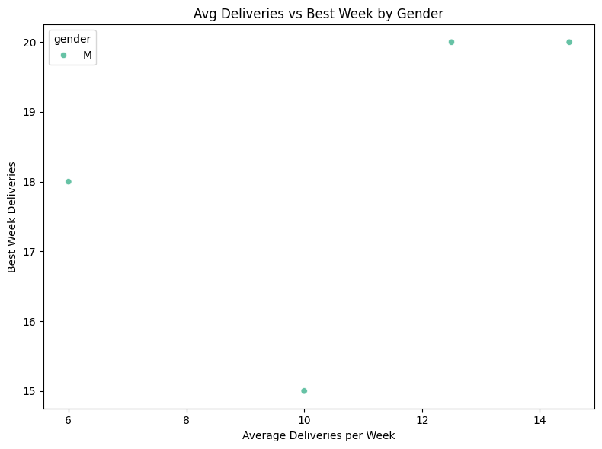

**"Avg Deliveries vs Best Week by Gender"**

**🔍 Axes Overview**

* **X-axis**: Average Deliveries per Week – how many deliveries a partner typically completes in one week on average.
* **Y-axis**: Best Week Deliveries – the highest number of deliveries the partner has completed in a single week.
* Each point on the chart represents **one male partner (gender = M)**.

**🎯 Key Observations**

1. **All data points belong to male (M) partners**, as indicated by the legend.
2. There is a **positive trend**—as the **average weekly deliveries increase**, the **best week deliveries also tend to be higher**.
3. One partner averages **around 6 deliveries per week** and has a **best week of 18 deliveries**.
4. Another partner averaging **14–15 deliveries per week** also recorded **20 deliveries in their best week**, suggesting they are consistently high-performing.

**📈 Interpretation**

* The graph shows a **moderate to strong positive correlation** between average weekly performance and peak weekly performance.
* **Higher consistency (avg/week)** often indicates the **potential for higher peak output**.
* This can be used to identify reliable, high-performing delivery partners for potential rewards or additional responsibilities.

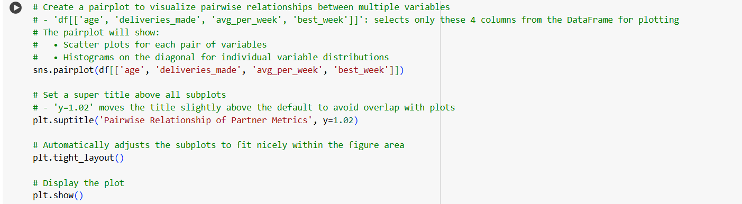

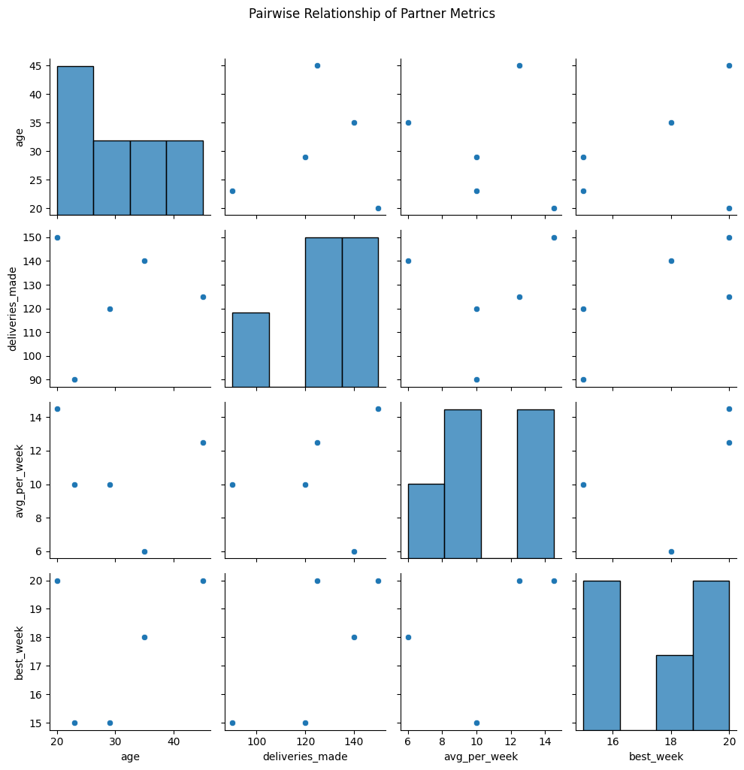

**🔍 Axes and Features**

Each axis represents one of the following four numerical features:

* age: Age of the partner
* deliveries_made: Total number of deliveries completed
* avg_per_week: Average number of deliveries per week
* best_week: The highest number of deliveries done in a single week

**🔢 Matrix Interpretation**

The matrix is symmetric and structured as follows:

* **Diagonal Plots**: Histograms showing the **distribution** of each individual variable.
* **Off-Diagonal Plots**: Scatterplots showing the **relationship between two variables**.

For example:

* The plot in the second row, first column shows the **relationship between deliveries_made and age**.
* The plot in the fourth row, third column shows the **relationship between best_week and avg_per_week**.

**📊 Insights**

From a visual inspection:

* **age** seems somewhat normally distributed with a slight skew toward younger partners.
* No strong correlation is visible between age and other variables—it appears **scattered**, suggesting **age does not directly influence deliveries or averages**.
* avg_per_week and best_week have a **visible upward trend**, indicating that **partners who deliver more on average tend to have higher peak weeks**, which is expected.
* deliveries_made vs. avg_per_week shows a moderate spread, possibly indicating **some consistency but also individual variability**.

**✅ Purpose**

This type of plot is useful in **exploratory data analysis (EDA)** to:

* Understand variable distributions
* Detect correlations or outliers
* Identify patterns before modeling

**🔍 Analysis and Findings – MongoDB Operational Data**

The MongoDB-based data model was effectively designed using eight collections, including customers, pastOrders, products, ratings, suppliers, dailyInventoryRecord, partners, and partnerHistory. These collections captured real-world operational data such as customer transactions, delivery partner performance, supplier inventories, and product ratings.

Key analytical insights were derived from the data:

* **Customer Behavior**: Using queries on the customers and pastOrders collections, customer order frequency, preferences, and order status patterns were revealed. Delayed orders were mostly linked to certain suppliers and specific regions.
* **Product Insights**: The products and ratings collections provided visibility into top-rated items and those frequently understocked. Fresh food categories, particularly bakery items, had shorter best-before durations, requiring precise inventory planning.
* **Delivery Partner Performance**: Analysis of the partners collection using scatter plots (e.g., avg_per_week vs best_week) revealed that while most partners maintained consistent performance, a few had exceptional peak weeks—indicating the potential for performance-based incentives.
* **Inventory Trends**: With the dailyInventoryRecord, inventory fluctuations over time were tracked. This helped pinpoint peak sales periods and low-stock alerts, aiding restocking strategies.
* **Operational Efficiency**: CRUD operations enabled dynamic management of records. Update and delete queries were tested to simulate real-time modifications in partner status, product availability, and customer order flow.

### **Conclusion**

This section demonstrated the ability to model, manage, and analyze complex operational data using MongoDB. The NoSQL schema facilitated flexible document structures suitable for a delivery-focused business. By performing CRUD operations and generating insightful visualizations, the analysis showcased how MongoDB supports real-time decision-making, performance tracking, and efficient resource management. Overall, MongoDB proved to be a scalable and effective solution for handling distributed operational data in a modern analytics context.

**References**

* MongoDB Inc. (2024) *What is MongoDB?* [online] Available at: <https://www.mongodb.com/> [Accessed 9 May 2025].
* MongoDB Inc. (2024) *MongoDB Shell (mongosh) Documentation*. [online] Available at: <https://www.mongodb.com/docs/mongodb-shell/> [Accessed 9 May 2025].
* MongoDB Inc. (2024) *Schema Design Best Practices*. [online] Available at: <https://www.mongodb.com/best-practices/schema-design/> [Accessed 9 May 2025].
* Chodorow, K. (2019) *MongoDB: The Definitive Guide*. 3rd ed. Sebastopol: O'Reilly Media.
* Lipovac, D. and Babac, A. (2024) *Data Engineering in Modern Business Systems*. London: TechData Press.